EV Charging Outlets at Appalachian Trail Heads in Maryland (rev c)
Bob Bruninga, PE - bruninga@usna.edu
Author: http://aprs.org/Energy-Choices.html

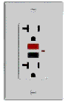
Hiking is the healthiest and cleanest carbon free form of transportation, burning nothing but a bit of trail mix for miles. On the other hand, it is a travesty when hikers use a gasoline powered SUV to drive up a mountain to and from the trail head that takes 6 gallons of gas just to get there! The Appalachian Trail spans 40 miles across Maryland and is one of the most popular outdoors and hiking destinations. This proposal suggests a partnership between stakeholders to install simple standard 120v outlets at the several trail heads in Maryland to provide a slow top-off L1 charge from 100% clean electricity for EV hikers to compensate for the energy used to get to the trail.
All EV’s come with a convenient 120v standard charge cord that can plug into any convenient standard 120v outlet. Thus, any EV when plugged in for say an 8 hour day hike can gain about 36 miles of EV range for the trip home. Not to mention the 7 miles per 1000’ feet recovered from the potential energy and regeneration on the way back down the hill.
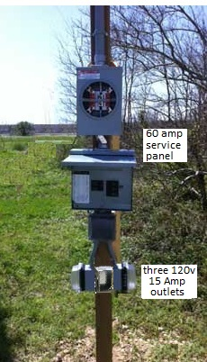
A good example trail head in Maryland is at Gathland State park. There is already transformer power in the parking lot as shown below left. All that is needed is the three outlets and a meter as shown at right added to the pole.
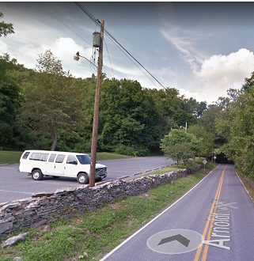
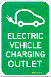
The cost to charge is about 20 cents an hour or about a worst case $2 per day for a car left there for 10 hours. Considering about 30% usage then the electric cost should be about $20 per month. The cost to install should be under $1000. Since the hardware is nothing but a few standard 120v outlets, this project does not involve any Charging Station hardware, nor contractors, nor expensive credit card devices nor networks nor special charging accounts nor cumbersome billing schemes. It is simply a one-time addition of standard outlets adjacent to the parking lot and placement of EV Charging Outlet signs.
Another example trail head is at Fox pass. It has a power pole in the parking area and should be easy to add a small 60 amp transformer and the three 120v outlets on the pole.
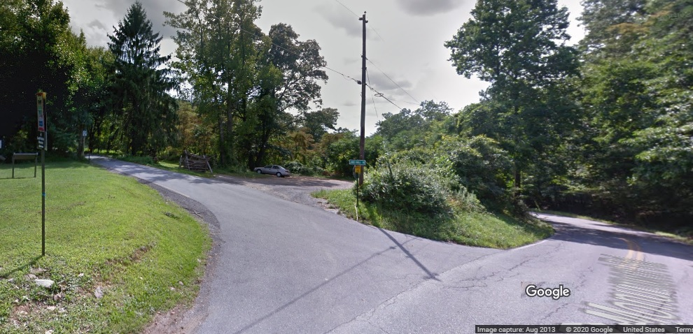

There are several ways to pay for this system. 1) a donation/sponsorship campaign; 2) an ongoing contribution to clean air from the park system or local Electric Utility or state; 3) A simple “iron ranger” (steel pipe with a dollar slot) for accepting fees like are used at several parks for after-hours fee collections.
Stake Holders: - MD EV Infrastructure Council for support and endorsement
- Potomac Edison as the local electricity provider
- Appalachian Trail Conference for identification of sites and promotion
- Maryland Department of Natural Resources – State parks
- EV Association of DC and Metropolitan areas
- Sierra Club and other clean-air interested non-profits
Trail Heads: - Harpers Ferry (power) - US40 Nat Pike (@ I-70) (power xformer)
- Weaverton Cliffs Parking lot (power) - Foxville Road (power poles)
- Fox gap (power pole)
- Gathland State park (power transformer) - Wolfsville Rd Parking Lot (no power)
- Washington Monument State Park (power) - Raven Rock Trail Head (no power)
- Old S. Mountain Inn (route 40) (power) - Warner Hollow Rd (no power)
- Pen Mar Park (power) - High Rock (no power)
I personally am considering a legacy donation if there is any way to get this project started. The first step is having Potomac Edison estimate the cost to install the above two examples and the estimated fixed monthly billing fees to help scope the overall cost.

This is an ideal project to promote clean energy in a highly visible location. An EV uses a lot of mileage range climbing to the top of a pass. But if they can top off for a few hours while hiking, then they can pick up plenty of miles for the trip home.
See examples of simple 120v EV charging in Maryland: http://aprs.org/EV-charging-signs.html
See WEB version of this proposal: http://aprs.org/EVs-and-AT.html

