SATT4 Design Documentation. PUBLIC (rev t) 27 Nov 2018
Bob Bruninga, WB4APR
Rev s 8 Nov 2018 added H1-16 data select driver of UHF PA to the schematic
Rev r 31 Aug 2018 revised list of future firmware ideas
Rev p 21 July 2017 Added HIPWR command to docs
Rev o 3 May 2017 Updates LEDS and power budget. May need much more from USNAP1
Rev n 7 Mar 2016 brings docs current with latest REV 3 board order
Rev m 2 Mar 16 updates due to lessons from PSAT-2 integration
Rev k 30 Jun 16 adds section on using PuTTy to configure it.

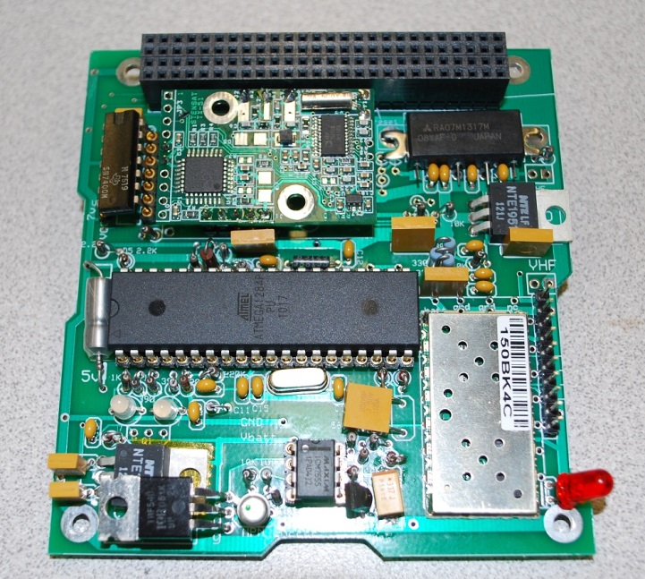
The design goal of the SATT4 board is to be a low cost AX.25 and APRS compatible Cubesat comms board for telemetry, command, and control and to encourage Amateur Radio missions on student cubesats compatible with the worldwide network of volunteer ground stations. The comm board usually works on 145.825 MHz half duplex at 1200 baud to provide this compatibility with the APRS global network while also providing for command uplinks and telemetry downlinks. This board also adds a CANSAT 9600 baud UHF downlink for higher data rate downlinks.
The board fits the cubesat-104 Bus standard.
The APRS mission extends the ongoing AX.25 packet radio space relay network pioneered by the US Naval Academy (USNA) since PCSAT-1 in 2001[1] and subsequent spacecraft [2] [3] [4] [5]. These satellites are vital in the amateur satellite service to provide a remote date relay for student and amateur experimenters around the world. This mission also encourages young people to participate in STEM related education with hands-on access to satellites that others can use and fit within the rules of the Amateur Satellite Service. The live data is visible at the bottom of the http://pcsat.findu.com web page.
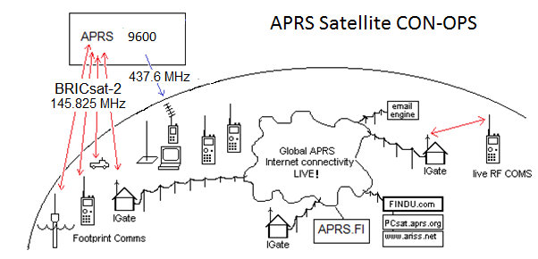
SATT4 Specifications: The SATT4 board’s VHF capability is a 2 Watt APRS transceiver capable of operating in the 2 meter amateur radio band. The board’s capabilities include the following:
- Design Operation from a 7 volt bus up to 12 volts max.
- An APRS Digipeater function to relay user packets from uplink to downlink
- Five analog inputs for simple telemetry in a 1-minute beacon
- 8 digital output bits that can be toggled by ground control for spacecraft functions.
- A serial port for uplink and downlink between other boards and the ground
- A CANSAT 9600 baud high speed UHF 2W downlink for data
- A Heartbeat watchdog timer that power cycles the board if Telemetry every fails
- An on/off Output bit and driver for an aux 200 mA load functions*
- A password protected uplink command capability*
- A post-launch TX holdoff delay*
(*) These items will require future firmware engineering from Byonics.com
The SATT4 Cubesat System: The board uses the processor and VHF XCVR of the Byonics.com MTT4B transceiver on 145.825 MHz. Data can be transmitted and received to and from the other cubesat boards via the internal TXD and RXD serial lines for the VHF link and can be transmitted on UHF via a TXD line to the CANSAT exciter for the UHF downlink. The CANSAT module is available from http://www.stensat.org/.
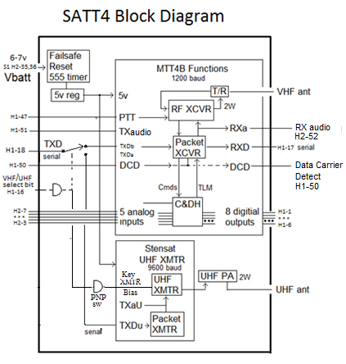
Figure 3: The SATT4 Inputs and Outputs
SAT-T4 APRS Comms Board: This comms board evolved from the MTT4B communications board available from Byonics.com. The earlier MT-TT4 was a precursor to the MTT4B and was flown by USNA on the PSAT-1 in May 2015 (and still operational). The MTT4B is the same basic system but with a new XCVR module and a 10W power amp for terrestrial use. In our design, we do not use the 10W PA but set the XCVR to high power (1.5W) with the new HIPWR=1 command. The default is 0.5W in low power. The current MTT4B has all of the functional capabilities that are needed for a Cubesat, however the dimensions of the MTT4B will not fit on the desired 10cm by 10cm satellite. Because of this, a new design was needed where the components of the MTT4B were rearranged to fit on a 10 cm x to cm board, and is shown below in figure 4. In addition, the 9600 baud UHF CANSAT module was included as well. The schematic is shown in Appendix A.
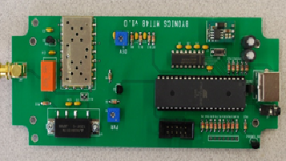
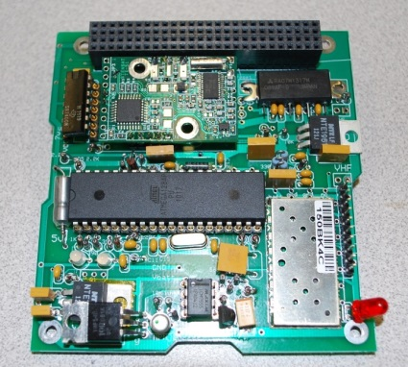

Figure 4. Layout challenge to reduce MTT4B Comm system to the SATT4 Cubesat-104 board

SAT-T4 Dual Bank Switching: The SATT4 can be programmed with two separate operating configurations or banks as detailed in Appendix B. The main use of this feature (on PSAT-2) is to enable and disable user digipeating and to change uplink frequencies. The configurations in Bank0 and Bank1 are switched on the condition of the JP1 bit (the 5th Telemetry channel input). By strapping one of the uplink command bits (!OUT $20) to the channel 5 telemetry input via a diode pulldown can give BANK 1 select underground control. When the bit is high (normal ops), the same pin can be used for an analog Temperature Sensor purposefully biased high so that it can never have a value that can pull the bit too low to cause the bank switch. When low (Bank1), the telemetry channel is meaningless.
Bank 0 - TOCALL=APOFF: Bootup mode with minimum power. Ch5 is valid.
Bank 1 - TOCALL=APDIGI: normal, Digipeater ON, TLM Ch5 is meaningless

The Bank-switch pin is JP1 which is also the 5th telemetry channel. Testing showed that the switchover point is about 460 out of the 999 possible telemetry range (almost half way) and that a 10k pull-up with a 7k pull down would not switch, but a 6k pull down would. To use one of the thermistors channels as the switch, we added a 10k in parallel to the thermistor to always keep the channel higher than the JP1 threshold and changed the R2 pull down to a 22k instead of a 10k to let it go higher and still remain above this threshold under all temperature conditions. Then the $20 command OUTPUT bit can pull it low to make the switch (and temperature is undefined in that state). But when the $20 bit is floating or high, then the thermistor can be read; thought it will need a its own calibration curve since counts will only be from about 700 to 999 over the temperature range.

SATT4 Telemetry: The SATT4 board includes an inherent 5 channel analog telemetry capability. These 5 channels report voltages from 0 to 5 volts as a count from 0 to 1024. The typical use of these channels are shown here.
Channel | Function | Pin # | Cubesat Bus | Notes
Ch 1 | System Voltage | PA7 / 33 | H2-7 R1/R2 On Comm board
Ch 2 | System Current | PA6 / 34 | H2-6 External
Ch 3 | Temp-SATT4 CPU | PA5 / 35 | H2-5 thermister on comm brd
Ch 4 | Temp-EPS | PA4 / 36 | H2-4 External
Ch 5 | Tbatt and Bnk-Sw | PA3 / 37 | H2-3 External but also bankSW | Shared w Bank switch

SATT4 Telemetry Formats:
The Telemetry downlink originated from the SATT4 can contain three internal SATT4 generated packets; These are the fixed BText, the fixed LTEXT and the 5 channel Telemetry. In addition, the downlink can contain ANY type of any other packet format sent to it from any other processor on the spacecraft on the TXD line. In addition the downlink will also contain any USER digipeated packets if the digipeater settings in the selected BANK are enabled.
SATT4 telemetry: PSAT-2>APRSAT,ARISS:T#SSS,111,222,333,444,555,10101010
SATT4 BTEXT: PSAT-2>APRSAT,ARISS:any fixed BTEXT you want to go here
SATT4 LTEXT: PSAT-2>APRSAT,ARISS:any fixed LTEXT you want to go here
Other CPU data:: PSAT-2>APRSAT,ARISS:Any other CPU data goes here
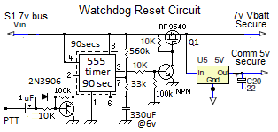
Watchdog Timer Reset Circuit: A special circuit is added to the comms board to recover the comms board from SEU events and latch-up and to reboot the comms board via a 2 second power-cycle whenever the 1 minute telemetry is lost. This circuit consists of a 555 timer chip and transistor switch to the input of a DC/DC regulator. The 555 chip is rated to 12 volts so a pair of series 0.7v diodes reduces the supply voltage into the safe operating range.

5V Regulators: The SATT4 contains a 555 Watchdog timer circuit and FET switch that will cycle power to the Vbatt bus if the SATT4 one-minute telemetry is lost. All circuit cards in the spacecraft with chips and processors can run from this protected Vbatt power and can be recycled in case of latchup or single-event-upsets in space. A second low-dropout regulator powers the separate higher current requirement of the UHF power amp directly from the battery lines since these passive componnents are keyed on/off and hopefully do not latchup..

The SATT4’s Power Budget is shown in Table 1. The SAFE mode currents represent the always-on loads on the spacecraft. The additional columns show the total load current in the additional modes. Currently the budget shows that not all modes can operate full time.

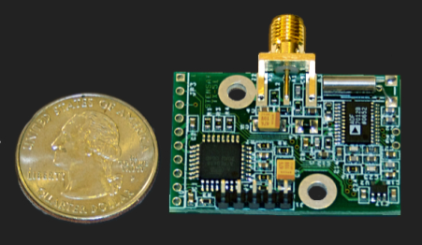
SubFunction Current Duty Safe mode Operate
----------------- ---------- ------- ------------ ----------
SATT4 RX 120 mA 100% 120 mA 120 mA
SATT4 TLM 750 mA 2% 15 mA 15 mA
UHF TX stby 20 mA*100% 0 20 mA
UHF PA stby 400 mA* 2% 0 8 mA
UHF XMIT 750 mA 2% 0 15 mA
------------------------------------------- ---------- ----------
Totals 135 mA 200 mA
* only drawn when UHF Select bit is LOW CANSAT UHF transmitter

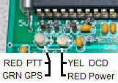
LED Indicators: The SATT4 has the same LEDS as the Byonics MTT4B. The function colors are as indicated here. To save about 5 mA of power, be sure to change the LEDS paramater to OFF in the final flight code at least in the default BANK0 (SAFE mode). Leaving them on in BANK1, which is usually enabled when there is plenty of power, allows you to send ground command and see the LED come on during final integration testing.

Sun Bit: To save power, there is a Sun-bit defined on the cubesat104 bus to indicate when the spacecraft is in sun. This can be used as a power-saving technique where applicable. The only power saving in the SATT4, however is to bank switch to a lower duty cycle operating scenario. In PSAT-2 this can mean turning on and off user digipeating. This bit could be used for example to power down about 10 minutes (TBD) after entering eclipse which should be when the spacecraft will be near local midnight depending on season. These systems then power back up about ten minutes later (TBD) to be ready at sunrise for user load. This saves about 10% of user load power (10 out of every 90 minutes).
High Speed UHF Downlink: The SATT4 board also includes a UHF 9600 baud downlink CANSAT transmitter made by Stensat with an added UHF power amplifier. The H1-18 TXD data line from the Cubesat is switched from the default 1200 baud VHF transmitter to the UHF 9600 baud transmitter when the H1-16 Select bit is pulled low. The TXD line is TTL level and is always operated at 9600 baud.
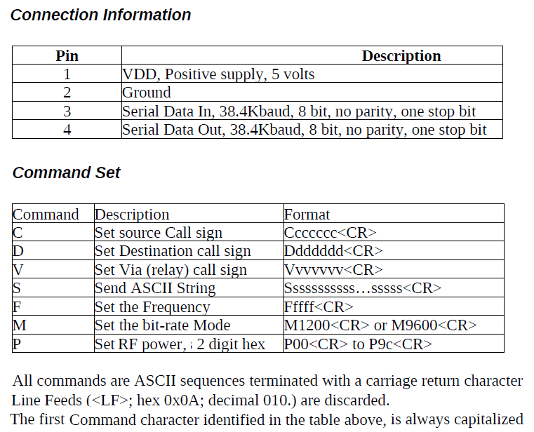
UHF Downlink Format: Note, The factory assembled CANSATs operate with a TTL input of 38.4 kBps and a channel rate of 1200 baud. We special ordered CANSAT modules set for 9600 baud TTL inputs though the channel rate still defaults to 1200 baud.. The command to change channel rate is M9600. The serial port rate cannot be changed. Any data to be transmitted on the UHF dowlink must have the first character be an “S” (for send) and be terminated with a <CR>. Any other character may be interpreted by the CANSAT as setup commands that can possibly scramble the CANSET settings. The CANSAT module commands are as shown above.
To Transmit on VHF: 1) Float or HIGH on H1-16
2) Send any data on the H1-18 serial TTL TXD line
3) End each line with a <CR>

To Transmit on UHF: 1) Ground or LOW H1-16
2) Send “M9600” once on H1-18 serial line
3) Send all subsequent
IMPORTANT: The H1-16 bit not only selects UHF, but also biases the final Power Amp in preparation for transmitting. Just turning on the bias draws 400 mA or almost 2 watts of wasted power. So be sure to always keep H1-16 selected HIGH when not transmitting. And for safety, in your main code periodically send an H1-16 HIGH just to make sure it stays that way except when actually transmitting.
SATT4B Uplink Command BITS: The SATT4B has a command BYTE consisting of 8 uplink command configurable output bits ($XX). The $02 (internal) and $20 bank-select bits are already used internally and should not be toggled. The rest can be defined for payload use. NOTE: The output bits are initially tri-state, meaning they are floating at a high impedance. It is best to design all control circuits to default to HIGH to match this condition and to be pulled low when commanded. As soon as any !OUT $XX command is sent, however, they are forced high and low as defined by the bits in the $XX command. So careful thinking is required. IE, a $00 command would turn on ALL FUNCTIONS at once. Conversly, a $FF command is benign because it simply switches the output bits from floating-to their default HIGH state. Also, always keep the $02 bit high since it is used internally. And be careful of the $20 bit because it causes a bank switch and that might change the callsign for subsequent commands. We hope the future flight SATT4 firmware allows these commands to be protected by a password system*.
Proper I/O Interface Design: It is important to think through what these bits are connected to, whether you want them active high or low, and what happens when the SATT4 power is temporarily removed and these bits go low. It is important to isolate them with a series resistance so that the SATT4 5v bus can go low during a reset (an external input held at 5v will hold the CPU still running!) Or what the external circuit on another card does to these as inputs when that board is powered down and drags them low. We finally settled on using these bits as active HIGH with pull down resistors to solve most of these issues.
SATT4 Command !OUT $XX bit designations –
Function | Bit | MTT4-B  I/O Pins | SATTT4B  Functioin | Wire  Use | Fig LLL. I/O Pin diagram | BS2  Pin
Tristate, floats before first cmd
$00 all functions off
$01 TBD | 1 | 22 / PC0 |  |  | 1 | 8
$02 SATT4 intl (xcvr setup) | 2 | 23 / PC1 | Sets RF Freq |  | 2 | 9
$04 TBD | 3 | 24 / PC2 |  |  | 3 | 10
$08 TBD | 4 | 25 / PC3 |  |  | 4 | 11
$10 AUX board PwrON | 5 | 26 / PC4 | Voice Pwr-on |  | 5 | 12
$20 Bank switch (only) | 6 | 27 / PC5 | Voice Audio |  | 6 | 13
$40 TBD | 7 | 28 / PC6 |  |  | 7 | 14
$80 TBD | 8 | 29 / PC7 |  |  | 8 | 15

SPECIAL FIRMWARE REQUIREMENTS FOR SATT4: These ideas will hopefully be negotiated with Byonics to make the SATT4 not only more useful for space but also for general users of the MTT4B product.
- A launch TX delay? (Can fix w TLM and DIGI commanding) – FCC REQUIRED
- Possible on/off BIT control of the GPS switch - nice
- Possible usage of the PD7 bit? And the PB4, 5 and 6 bits? - nice
- Possible XCVR settings for PL, squelch or power saving? - DONE
- Password “abc” string protection on the !OUT $XXabc cmd - GOOD FOR ALL
- De-conflict use of PA3 analog input for Bank Switching - NEEDED
- Extension of !OUT $XX commands to include:
$K0/$K1 for setting bank 0 or 1
$T0/$T1 for setting Telemetry On/Off, and timing
$U0/$U1 for turning on and off User digipeating
$S0/$S1 for turning On OFF the Status Beacon
$G0/$G1 turning On/Off the GPS power control bit

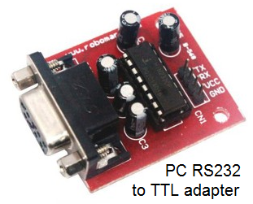
Configuring the SATT4 Settings:
Serial Port: A big difference between the SATT4 and the stock MTT4B is the absence of a MAX232 TTL to RS-232 conversion chip. This chip is noisy and reduces RF receive performance by as much as 8 dB, so it is not used on the SATT4. So the serial TXD line on the SATT4 is TTL sense-and-levels whereas on the MTT4B they are RS232 sense and levels (inverted from each other).
GSE and Configuration Connector: We use an RS232 to TTL adapter to connect to the GSE (Ground Service Equipment) pins on the SATT4 for working with a PC. This connector also has the TXD and RXD from the 104 bus on other pins so they can be separately used for troubleshooting. For flight, two jumper wires are used on the flight GSE plug to connect the SATT4 serial TXD and RXD to the other board’s TXD’s and RXD’s. Notice that all boards can monitor the SATT4’s RXD. But if they want to transmit, they should be hard pulldowns and light pullups so these multiple drivers are not fighting each other.
Dual Ports: Also notice that the MTT4B and SATT4 actually have two serial ports. The A port is used for firmware loading and general serial communications and the B port was designed in the original MTT4B for connection of a 4800 baud GPS. We do not use GPS on a cubesat, so we configure this second port to operate at 9600 baud as a second serial text data line using the BMODE = TEXT and BBAUD = 9600 commands.
To configure the SATT4, connect a PC serial port via an RS232 to TTL converter to the TXD and RXD pins on the GSE connector 3rd and 4th pins up from the bottom (pin 2 is Gnd). This is Port A. The converter we used also needs 5v to power it so the 7th pin up provides that power. Prepare your terminal program to operate at 19.2 kbps. (We used PuTTY).
Power up the SATT4 board and within the first 3 seconds you will see the message “Hit ESC three times to go to setup”. If you do that correctly, you will get the SATT4 prompt. At this point, you can type any of the commands (without their parameters) as shown in Appendix B to see the current settings. Be careful. Any change you make will be remembered.
Once you have finished checking or changing parameters, you can cycle power to return to normal operations or you can type the QUIT command. Remember, during normal operations the baud rate will be whatever is in the ABAUD and BBAUD commands. The 19.2 kBaud is only required for entering the settings mode in the first 3 seconds.
A complete list of all commands is in the byonics.com doucmentation for the MTT4B or the TinyTrack 4.

References:
[1] http://aprs.org/pcsat.html The original USNA APRS Satelliet PCSAT-1
[2] http://aprs.org/pcsat-2.html PCSAT-2 flew attached to the ISS in 2006
[3] http://aprs.org/ande.html ANDE Deployed form the ISS in 2006
[4] http://aprs.org/raft.html RAFT Deployed from the ISS in 2006
[5] http://aprs.org/psat.html PSAT-1 deployed in May 2015

Appendix A: This does NOT have the many changes for the final USNAP1 with UHF

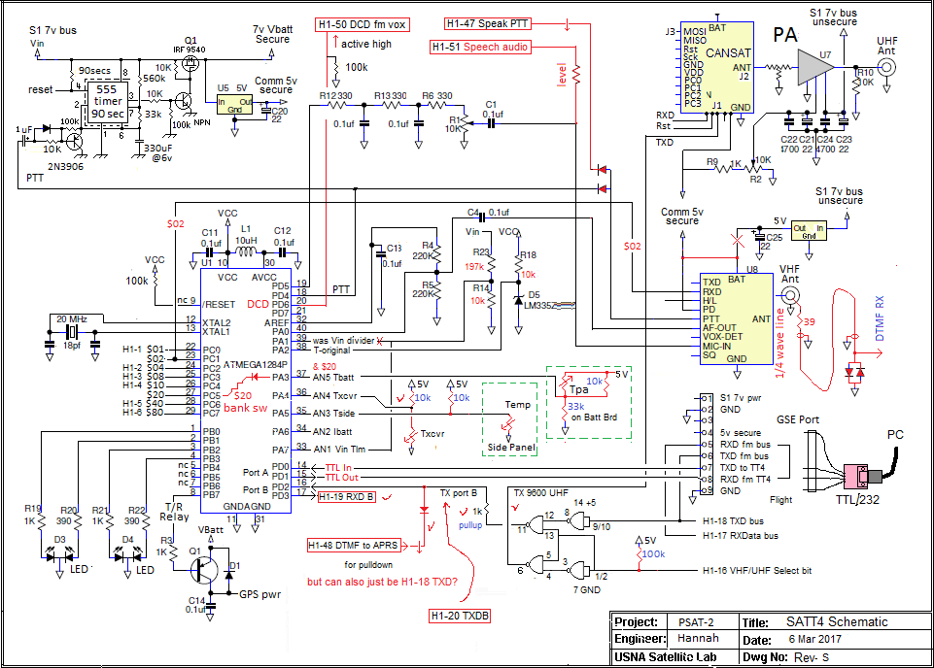
* - FOUO - *
Appendix B. Setup and Programming commands for SATT4 Processor v0.70. The SATT4 has two banks for two different flight configurations. We normally configure the default BANK0 for minimum power mode with just telemetry and no user digipeating. The other bank1 can be commanded via the JP1 in flight. In this bank, we usually have user Digipeating enabled.

Command Default BANK0 BANK1 (same as Bank0 except…)
---------------- --------------- ------------------------------- ----------------------------------------------
MYCALL NOCALL PSAT-2 PSAT-12

ABAUD 19200 9600 * (* means same)
ALIAS1 TEMP secret APRSAT these 3 enable digipeating
ALIAS2 % none ARISS
ALIAS3 % none WIDE
ALTNET APTT4 APSAFE APDIGI
AMODE Text text *

BANK 0/1 0 0 1 set during programming
BBAUD 4800 9600 *
BMODE GPS text *
BNKMODE 0 1 * uses JP1 for bank switching
[uses PA3, CPU pin 37, J3?]
BPERIOD 0 175 * <a 3 minute beacon text>
BTEXT >TT4 alpha >BANK0 Beacon text >BANK1 Beacon Text

CDMODE Tones ***Inverted -pin2 * <J1 pin 2 [CPU pin 20] to holdoff XMT>
DIGIID true true * <inserts MYCall in digipeated packets>
DIGIMY false TRUE *
DUPETIME 30 10 *
HEADERLN false false *
LEDS true OFF * TRUE
MSGCMD false true * <allows !OUT $xx commands to BS2 CPU >
NODISP false true * <Required for $xx PortC msg commanding>
PATH1 WIDE1-1 ARISS (via ISS) *
PATH2,3 WIDE2-1 (none) *
PKTICOM true true * <Enables received packets to PC text port>
PKTOCOM False true * <Lets hiSAT see our TX packets also>
PPERIOD 0 0 * <posit Prd (In sec), not used on QIKcom2
RXAMP 5 5 5 * <RX gain. Use MONITOR mode to adjust>
TELHIRES true true * <enables 0-999 values>
TELVOLT true False *
TELTEMP true False *
TELREAD true False * <Turns off human readable telemetry>
TPERIOD 0 60 * <Telemetry Period >
TXD 40 30 * <20 = about 150ms>
TXLEVEL 128 128? * <TBD for flight>
TXTWIST 50 50? * <TBD for flight>
TXFREQ 144.39 145.825 * can change in bank 1
RXFREQ 144.39 145.825 * can change in bank 1
RXSQUELCH 1 2 2
HIPWR 0 1 1 sets power to 1W not 0.5W

Appendix C

The definitions of the pins of the Cubesat bus used by the SATT4 are indicated in the notes across the top. The command bits are on the left. Then the analog bus pins, some serial data pins then the battery and separation switch bus. Finally, on the right are four User defined pins and the six special user pins used for our particular PSAT-2 which have to do with sharing data and TX audio with the DTMF/Voice system. This does not have the final arrangements used for UHF on USNAP1.

