QIKcom2 Module System Design - FLIGHT UNIT sn#2 (OK-a) 24 Apr 2019

(does not contain command codes)

Team: Bob Bruninga, MIDN’s Segalla, Skinker, Diaz-Ordaz, Hunt

Rev p contains late stuff added in 2017? Such as QST Voice message upload?
Rev o added CONOPS drawing
Rev m was flight docs as delivered 18 Nov 2015

Serial #1 was shipped with document rev (d). This document (rev L) updates through work on SN#2 shipped 18 Nov 2015. Rev m completes the calculation of the Moments of Inertia in the section on Mass Budget, page 10.

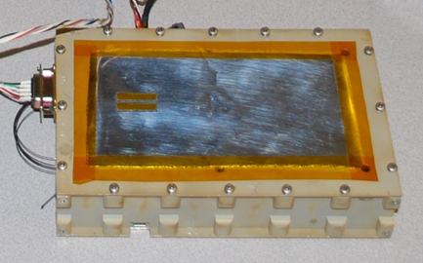

The US Naval Academy (USNA) QIKCOM-2 module (Sn#2) shown above, is a small 4”x7”x 2” flight module (600 grams) consisting of a communications transponder payload that will be integrated onto the free-flying eXCITe spacecraft using a NovaWurks Universal Device Adapter(UDA) as shown in figure 1 below. The target delivery of the transponder Engineering Unit to NovaWorks was 5 June 15, 2015 with one flight unit by 28 July and the second by 6 Aug (delayed to 18 Nov) for launch in Spring 2016. This is an initial flight test payload development, with additional potential payload opportunities possibly becoming available further in the future.

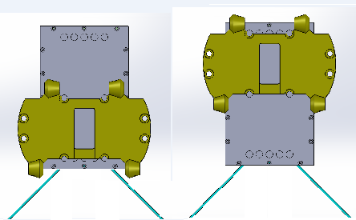
Figure 1. Showing two possible configurations of the QIKCOM-2 module (gray) on the UDA(gold) with the two orthogonal VHF whip antennas (blue). One on the left is most likely flight configuration.

Mission: The primary mission, also defined on the QIKCOM-2 mission web page [1], is to provide another Packet Radio Transponder in support of the prior USNA data transponder missions providing remote data relay in the Amateur Satellite Service while demonstrating Quick Reaction to spaceflight launch opportunities. Prior USNA transponder spacecraft supporting this mission were PCSAT-1[2], PCSAT2[3], ANDE[4], RAFT[5] and recently PSAT[6] in May 2015. These spacecraft relay user data to volunteer ground stations around the world making this data available live on public web pages[7]. In addition, QIKCOM-2 adds a new capability to handle touchtone keypad data and messages from less-expensive radios using a CPU, DTMF decoder, text-to-voice chip, and voice synthesizer. A sample of typical user communications on a few passes over Europe are included in Appendix F.
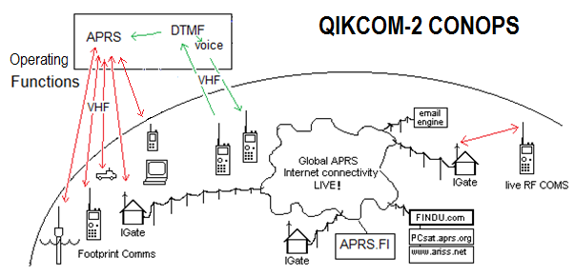
Background: With the significant popularity of CubeSat modular spacecraft on the order of dozens of launches per year, launch opportunities come and go as schedules expand and contract. The development time for previous USNA satellites have taken between 1-6 years and have not been able to react to short term launch opportunities. This QIKCOM project was developed to be more responsive to short-fuse opportunities. Such an opportunity became available in August 2014 leading to the project to deliver a QIKCOM-1 flight unit by March 2nd, 2015, and now a follow-on QIKCOM-2 flight opportunity for delivery by August 2015 for SN1 and November for SN2.

QIKCOM-2 continues the APRS Packet Radio Data transponder of prior USNA missions but these missions were only usable by about 10% of the users who operate the more expensive radios with internal APRS modems and displays. To extend APRS to all users with less expensive radios, the students developed the quick response communications payload QIKCOM-2 to not only bolster the APRS network at minimal cost, but to also provide access to an order of magnitude more users that can use any radio with a TouchTone Keypad. In APRS this is called APRStt [8], but the generic name for the “touchtone” code is Dual Tone Multi-Frequency or DTMF. These users will send their data in short DTMF bursts and QIKCOM-2 will convert it to APRS packet protocol for the downlink and also acknowledge the DTMF uplink with synthesized voice.

Using COTS devices, the cost for QIKcom2 is under $15k, and will incorporate an APRS transponder module, Voice System CPU control board, DTMF decoder and Voice Synthesizer package to provide all Amateur Satellite and APRS users across the globe with reliable access. Furthermore, the CPU allows certain ground control stations to control the DTMF-to-speech system voice loading to prevent congestion. The host spacecraft can also enable or disable the DTMF/Voice system. Proven effective, this affordable and standardized communications bus can revolutionize the Amateur Satellite network by improving access to a larger category of users and provide continuity in network operations. The specific downlink from QIKCOM-2 will be routed to the same web page as the other USNA satellites[9][10].

APRS Packet Radio Transponder Functions:

APRS data from ground radios using 1200 baud AX.25 packet protocol is received through the Byonics.com MTT4B packet transceiver on VHF. The APRS user data is repeated back to Earth (digipeated) in real-time but is also monitored for spacecraft commands while in APRS-to-speech mode. In this APRS-to-speech mode, specialized message packets from APRS users can be spoken by QIKCOM-2. One such command is to upload a Speech Bulletin to be repeated worldwide every 4 minutes. But this mode and the DTMF-to-speech modes are mutually exclusive due to BS2pe processing limits. A ground command can switch between the modes. The MTT4B also has 5 external analog inputs for telemetry reporting bus voltage, system current, and three temperatures in the module. It also has 8 on/off command bits under ground control used for controlling the speech processor.

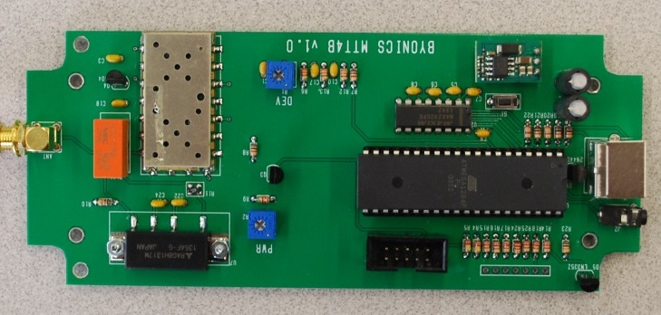

Figure 2. Commercial off-the-shelf Byonics.com MTT4B Packet Radio

The MTT4B transceiver (Figure 2) supports the primary transponder mission. It is a frequency agile APRS transceiver that operates on 145.825 MHz. It transmits the 5 channel telemetry once a minute and digipeats user packets to other ground users and the internet via volunteer ground stations. The 10W output of the MTT4B is adjusted down to 4 Watts to save spacecraft power but is more than adequate to close the link to users with handheld radios. The transmitter output then drives a 90 degree phasing hybrid to drive the orthogonal whip antennas for cross polarization. A schematic of the MTT4B is shown in Appendix A and wiring connections in Appendix B.

The MTT4B has dozens of configuration setup parameters that need to be tailored for this mission. These parameters are stored in two personality banks, BANK0 the default which has APRS digipeating disabled and the second BANK1 that can be enabled by ground command to enable digipeating. The bank0 disables generic user digipeating using conventional path aliases so the mission can better demonstrate the new DTMF/voice capability. In this mode it also can support a special digipeating alias that will only be used by special users for special events. Figure 2 illustrates the commercial MTT4B being flown on QIKCOM-2. The programming of these banks is shown in Appendix C.

MTT4B Dual Bank Switching: The two MTT4B operating configurations in Bank0 and Bank1 are switched on the condition of the JP1 bit (the 5th Telemetry channel input). By strapping one of the uplink command bits (redacted) to the channel 5 telemetry input via a diode pulldown can give BANK 1 select under ground control. When the bit is high (normal ops), the same pin can be used for an analog Temperature Sensor purposefully biased high so that it can never have a value that can pull the bit too low to cause the bank switch.

- Bank 0 - TOCALL=APDTMF: Special mode and minimum pkts to interfere with voice
- Bank 1 - TOCALL=APDIGI: normal, Digipeater ON, TLM Ch5 is meaningless

The Bank-switch pin is JP1 which is also the 5th telemetry channel. Testing showed that the switchover point is about 460 out of the 999 possible telemetry range (almost half way) and that a 10k pullup with a 7k pull down would not switch, but a 6k pull down would. To use one of the thermister’s as the switch, we added a 10k in parallel to the thermistor to always keep it higher and changed the R2 pull down to a 22k instead of a 10k to let it go higher and still be above this threshold. Then the OUTPUT bit can pull it low to make the switch (and temperature is undefined in that state.

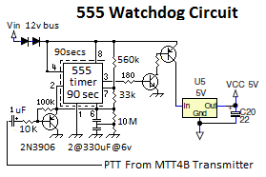
Watchdog Timer Reset Circuit: A special circuit (Figure 3) is added to the Comms board to protect the Comms system from SEU events and latchup and to reboot the comms board via a 2 second power-cycle whenever the 1 minute telemetry is lost. This circuit consists of a 555 timer chip and transistor switch to the input of a DC/DC regulator. The 555 chip is rated to 12 volts so a pair of series 0.7v diodes reduces the supply voltage into the safe operating range. Figure 3. Watchdog Reset Circuit

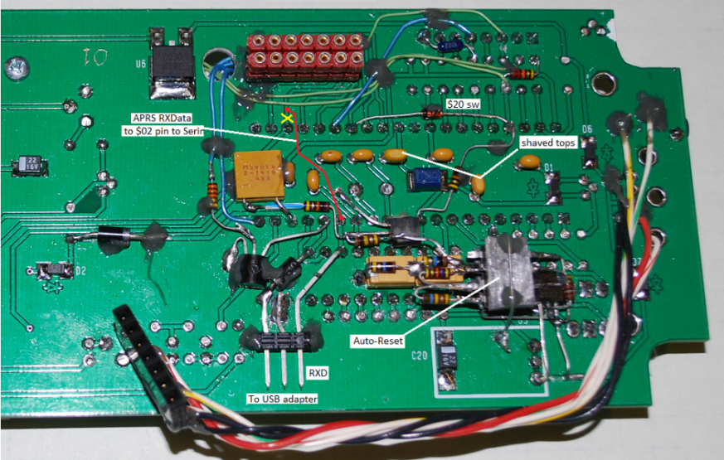

Figure 4. QIKCOM-2 mods to the MTT4B. Re-uses $X2 line for APRS RX data, straps $2X to the Telemetry and Bank Select. Also the USB connector and the 555 Timer reset system.
The numerous mods to the MTT4B system to configure it for QIKCOM-2 functionality are shown above in Figure 4. All components are staked with epoxy and have survived vibration tests.

Telemetry Formats:
In addition to the nearly infinite variety of User data packets relayed via QIKcom2’s downlink, there will be three QIKCOM-2 formatted packets, the BText and Telemetry from the MTT4B and two on host satellite health. In addition the Voice CPU may send down a daily email listing all DTMF user callsigns [No, ran out of code].

MTT4B telemetry: QIKCOM-2>APRSAT,ARISS:T#SSS,111,222,333,444,555,10101010
MTT4B Status: QIKCOM-2>APRSAT,ARISS:DTMF,W3ADO CQ APRStt
HOST GPS data:: QIKCOM-2>APRSAT,ARISS:}QA… (NovaWurks GPS data)
DTMF/Voice System: QIKCOM-2>APRSAT,ARISS::EMAIL----:wb4apr@amsat.org Grids: XX, Calls: YY, Msgs: ZZ

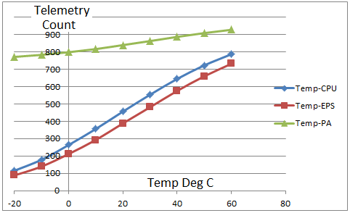
Figure 5. Temperature telemetry curve for Q2 SN#1

The CPU and EPS temperature curves are similar but the PA curve is highly loaded to make sure the bit can be shared with the bank switch and will be above 500 all the time (making it a logical 1). When this is pulled to 0, it also does the Bank switch command and the temperature is meaningless.

NOTE: On QIKCOM-2 thermistors are the tiny teardrop devices and a 10k pulldown is used.

Telemetry Port MTT4B I/O Port C bits: (Still for Q1)
As on PSAT As on PSAT (Confirm for Q2)

1. GND 1. GND
2. VCC 2. PC0
3. PA3 Ch 5 T-PA - Also Bank Select) 3. PC1
4. PA4 Ch 4 T-EPS 4. PC2
5. PA5 Ch 3 T-CPU MTT4B 5. PC3
6. PA6 Ch 2 Bus Current 6. PC4
7. PA7 Ch 1 28v bus input 7. PC5
8. +5 Volts 8. +?8 volts VCC?

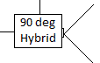
Antenna Phasing Design: The antenna system has orthogonal antennas to give an onmnidirectional pattern to serve all users in the footprint. By using a pair of quarter-wave whip-antennas fed 90 degrees out of phase we get an antenna pattern without serious nulls. The broadside of one whip effectively fills in the nulls in each other’s’ directivity. The antennas come out the end of the QIKCOM box after release by the burn resistor. The 90 degree phasing is achieved with a 12.75” quarter wave length of 50 ohm coax [arguably not matched].

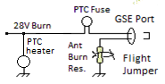
Antenna Release System: For antenna deployment, a burn-resistor melts a taut nylon line which holds the antenna wire coiled against the structure. The antenna wires are two orthogonal 20” long Nitinol wires which spring outward to their final position when released by the string. The antennas are coiled in separated mechanical slots. They are wound in two concentric circles in the two slots mounted on the EPS board as shown in Figure 6. Also shown are the pre-launch antenna tip measurement.

The original burn resistor was changed from 220 ohms to 330 ohms so that its circuit can also be used as a system heater in case of extreme cold. The burn release is now nominally at 7 seconds, so a 2X safety margin would suggest a 15 second burn. The 330 ohm resistor will heat without destruction. The 220 ohm one would smoke to black. The PTC heater can draw as much as 500 mA in extreme cold. The parallel combination of the PTC heater and the 220 ohm burn resistor now is a nominal 38 ohms as measured at 20C on the GSE test port to ground.

A separate PTC fuse is also included in series with the burn resistor to assure fail-safe operation from the host power bus. The PTC fuse “hold” current is rated at twice the expected burn current. Q1 is shown on the left and Q2 Sn#2 is shown on the right with both antennas being the same circle diameter.

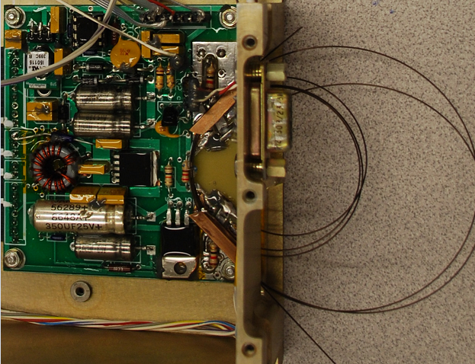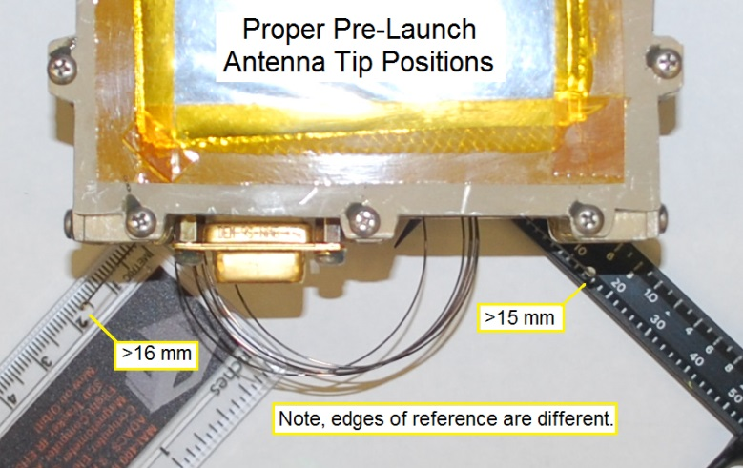

Figure 6. Antenna deployment system on the EPS board and final antenna measurements.

Table 2. MTT4B Analog pin assignments for Telemetry
Channel | Function | Pin # | Notes
Ch 1 | System Voltage | PA7 / 33
Ch 2 | System Current | PA6 / 34
Ch 3 | Temp-CPU (MTT4B) | PA5 / 35 | Wire used for ???
Ch 4 | Temp-EPS | PA4 / 36
Ch 5 | Temp-PA and Bnk-Sw | PA3 / 37 | And Bank switch

Module Structure:
The driving requirement for designing QIKCOM-2’s structure was that the overall mass be under 600 grams (Flight unit 1 came in at 612g and unit #2 at 599g). The housing structure shown in Figure 8 is made of Aluminum 6061. The overall dimensions for QIKCOM-2 are 7” x 4.3” x 1.60” with a 0.02” tolerance. The holes for all stacked components to attach to the baseplate are counter sunk such that QIKCOM-2 can rest flush against the host satellite. As can be seen in Figures 8, extrusions have been made to the front and side plates to minimize mass.

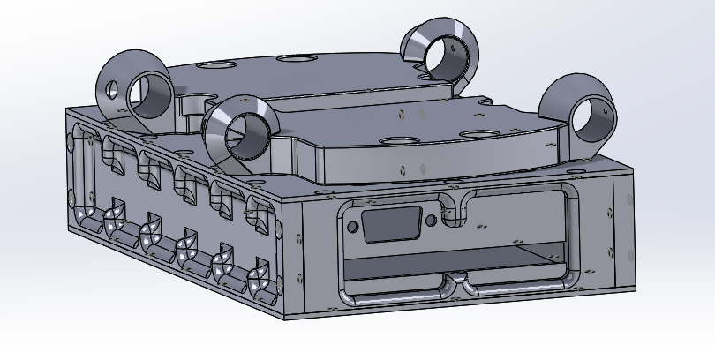
Figure 8. Q-2 on bottom mounted to the UDA (on top)

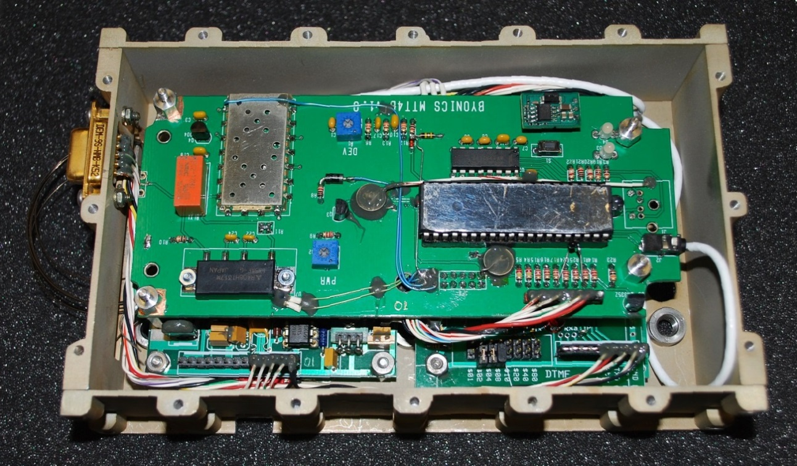

Figure 9. Assembled circuit board stack with MTT4B on top and antennas to the left.

Inside the QIKCOM-2 housing, the boards are stacked from the bottom up with the EPS board on the lower left and the Voice DTMF board and VHF receiver (under) on the right as shown in figures 9 and 10.

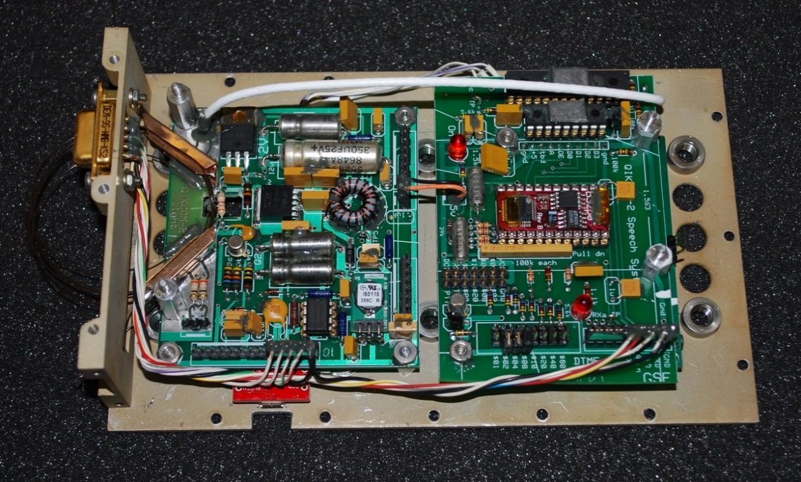

Figure 10. Lower boards with EPS on left and Voice CPU board on top of VHF RX board on the right.
Stack Budget: The QIKCOM-2 structure is 1.62 inches tall, including the top and bottom plates. Figure 11 shows the stack height budget with all of the circuit boards inside of the QIKCOM-2 structure.

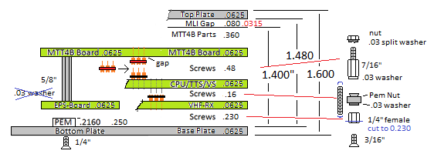
Figure 11. The stack height budget to fit in the box

The stack on the ride side of the structure, from the top of the MTT4B circuit board to the screws, sums above to 1.448. This allows for 0.032” clearance. The receiver board was inverted to minimize the board-to-vox-board spacing..
Table 3. Mass Budget for QIKCOM-2
Parts | Mass (g)
Box (2 sides, Front, Back Panel, Top Plate, Bottom Plate, Screws) | 315.2
MTT4B Board | 83.7
DTMF Receiver Board (all) | 47
MARGIN on DTMF Rx brd | -10
CPU/TTS/VS Board | 36.9
EPS/Antenna Board | 67
Antenna Wires | 1
Antenna Coax and Phasing | 22.3
6 PEM Nuts | 15.9
Wiring Harness | 9.1
Harwin | 2.1
DB-9 | 4.4
USB Interface | 2.6
MARGIN on side panels | -6
 | 591.2
Mass Budget: The mass budget in Table 3 was measured on the Engineering flat-board model. Final mass for flight unit #1 was over budget at 614 g and the flight unit #2 came in at 599g after extensive trimming of the box.

Flight Mass: Sn#1 612 g Sn#2 599g
CM from center of Unit: - 0.02 in X -2 mm
- 0.03 in Y -3 mm
- 0.10 in Z -10 mm

Moments: Moments were calculated in comparsion to a known cylinder on a string torsion balance. The relationships between the string’s Torque(T), spring constant (K), angular period (P), angular frequency (Ω) and moment of inertia (I) are: T = K * θ with the angular period, , where Ω = 2 π f and f = 1 / P. Solving for K from the test cylinder and unknown item under test, and then setting K equal we get I₁/P₁²= I₂/P₂² The moment of inertia of the cylinder is given by I₁=mr²/2 with mass = 862g and radius 2.54 cm or 5561 g.cm² or .000278 kg.m².

With this we can solve for the relative moments of Inertia of QIKCOM-2, Ix,Iy,Iz.

Half period of 862g test cylinder is 30s Ic=.000278 kg.m²
Half period in X is 51.5s Ix=.00082 kg.m²
Half period in Y is 81s Iy=.00203 kg.m²
Half period in Z is 91.5s Iz=.00255 kg.m²

Power System Design / Budget: The 28v spacecraft input power supply is regulated down to internal operational voltages of 12 and 5 volts through high efficiency DC/DC converters. Each component power requirements were considered in the Electrical Power System Budget. The computed overall orbit average current was 100 mA (estimated) for APRS packet operations and 150 mA including DTMF-to-voice. The max current was 500 mA on engineering unit tuned to 4 Watts. But with shorted antennas for flight is only showing about 300 mA. The computed average power then on the 28v bus was therefore 4.2 W and max power was 14 W. Table 4 shows power requirements for each component.

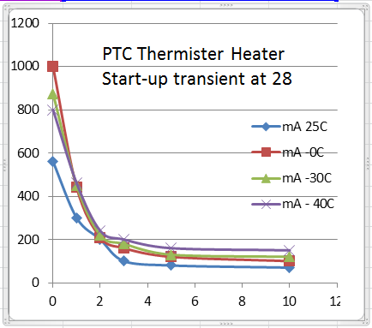
PTC Heaters: In order to remain within temperature limits within the QIKcom2 module, several PTC thermistors were included to provide minor 5v heating of key components if temperatures drop below 30C. The current for these heaters is minimal (about 20 mA at room temperature) and a maximum of about 100 mA at -20C). There is a 5v one along side the MTT4B CPU and another one in the center of the MTT4B board connected to the 28v burn circuit that can provide 5 times more heat if needed as shown in Figure 14. These thermistors are self -regulating to 30C meaning that they draw current up to 30C and then transition to high resistance to maintain that temperature. As a result, there is a starting transient as shown in Figure 10. Worst case is at 0C when the initial current is 1 amp but quickly tapers to under 200 mA in 2 seconds. Even at -40C the transient is only 800 mA tapering to 200 mA in 3 seconds. The parallel combination of the PTC heater and the 220 ohm burn resistor now is a nominal 38 ohms as measured at 20C on the GSE test port to ground.
Figure 12. Transient current of PTC heaters

The power budget for user demand assumes that APRS users around the world account for approximately 10% of the viewing area of the satellite. Although a 50% percentage of transmitting / receiving theoretically occurs during half-duplex full load operations, the more practical limit is about 40% due to collisions from packet overlap. Therefore, the orbit average transmit duty cycle was calculated to be 4%.

Table 4. Design Power budget for QIKCOM-2 Table 5. Telemetry assignment

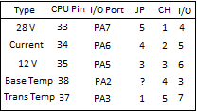
Actual: 450* mA pk, 90 mA idle, 140 mA with DTMF/voice on
* with antennas stowed and shorted. 610 mA flight.
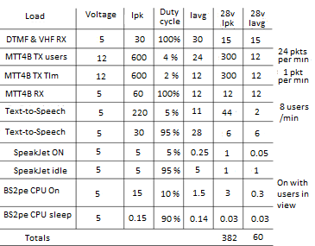

Telemetry System Design:

Telemetry data from the 5 analog sensors is generated and transmitted by the MTT4B every 60 seconds. Table 5 above right shows the maping of the sensors (needs updating) to the proper MTT4B pin via the various connectors. Each packet looks like this:

QIKCOM2>APDTMF,ARISS:T#001,171,055,113,441,440,01000100

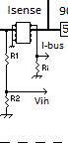
Telemetry Current Sensor Design: The Load Current sensor (right ) was designed to monitor the current being drawn from the host spacecraft. The average current is 70 mA and the max current 1 A. The sensor is a MAX471 chip capable of up to 2 amps sensing. The sense resistor Ri determines the scale and conversion factor from Icurrent to Vin volts. To read a current up to 1 amp, Ri needs to be 10 k-ohms using the relationship 2 k-ohms is equal to 1 V/A. Thus, at 5 V and 1 A, a 10 k-ohm resister is required. This was scaled in telemetry so that a count of 999 means 999 mA.

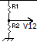
Telemetry Voltage Sensor Design: The Voltage Sensors are designed to monitor both the 28 volt input and the output from the 12 V regulator. The voltage dividers (right) were chosen with R1 being 187 k-ohms and R2 as 10 k-ohms to scale the 0-28 Volt inputs down to the A/D range of 0-5V which is then represented in a 10 bit A/D by counts from 0-1024. With these values, the raw telemetry counts will equal the voltage in tenths. So 286 means 28.6 volts.
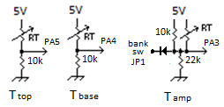
Telemetry Temperature Sensor Design: Two temperature sensors provide the temperature of the top and bottom circuit boards which are exposed to the two opposite thermal conditions on the Q-2 structure. A similar voltage divider (above right) is used to convert the temperature of the thermistor to a telemetry count. The thermistor RT is 10k at 25 °C and R2 is chosen also as 10k to center the temperature scale on 25 °C.

The third thermistor on the transmitter PA uses the PA3 (Ch 5) analog input that also serves as the bank select bit driven by the $20 command bit. When high, $2X with digipeater OFF, then, the thermistor is available. When $0X is sent, then the bank switches to support digipeating and the temperature count is meaningless. The diode isolates the Thermister circuit from the I/O pin when it is floating and un-defined (until the first $xx command is sent after a reset.

Telemetry default: QIKCOM-2>APDTMF,ARISS:T#SSS,284,037,516,516,810,00000000 T valid 26C
Telemetry with $2X: QIKCOM-2>APDTMF,ARISS:T#SSS,284,037,516,516,776,00000100 T valid 26C
Telemetry with $0X: QIKCOM-2>APDIGI,ARISS:T#SSS,284,037,516,516,567,00000000 T undefined
Wiring Summary:

Figures 13 and 14 illustrate the wiring between the NovaWurks host satellite and QIKCOM-2. All connections are made through two Harwin connectors in the same approach as QIKcom-1.
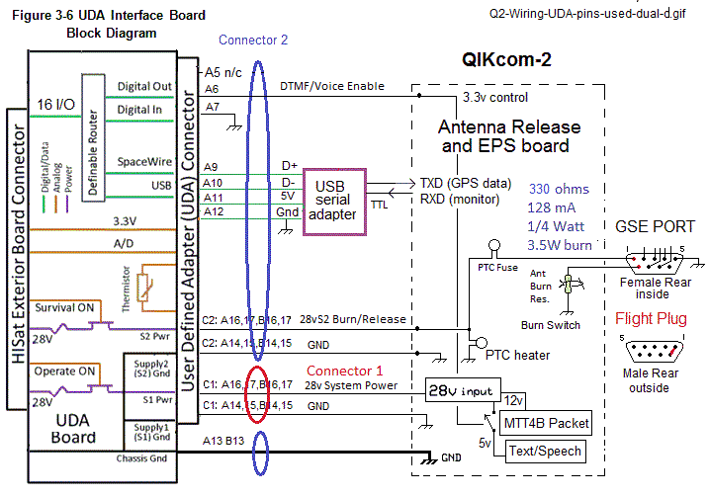
Figure 13. Wiring schematic between host and QIKCOM-2

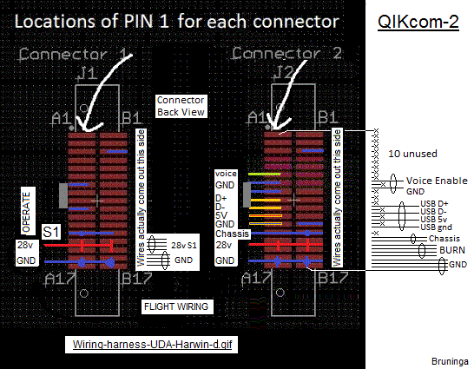

Figure 14. Harwin connectors diagram

Secondary Communications Mission, DTMF and Text to Speech payload:

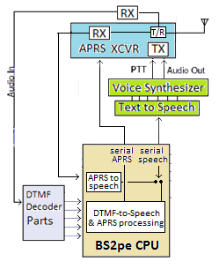
APRStt and DTMF-to-Voice: APRStt is the APRS TouchTone system using a DTMF uplink and Voice downlink capability. This mode is crucial to the widespread use of QIKCOM-2 by allowing non APRS capable radios (those with DTMF keypads) to utilize it and receive feedback responses to their DTMF uplinks. The DTMF-to-voice process consists of two chips; the Text to Speech (TTS) chip and the voice synthesizer (SpeakJet) chip as detailed in appendix D. The TTS receives up to 128 characters of serial data from the CPU. The TTS then converts the English text to SpeakJet allophone codes and sends the converted allophone codes to the SpeakJet via a serial pin. The SpeakJet is configured with 72 speech elements which will be used to output synthetic sound. The SpeakJet output will then be transmitted to Earth via the VHF transmitter on the MTT4B. While the MTT4B transmitter is transmitting speech, the Data-Carrier-Detect (DCD) pin of the packet processor is held high to hold off packet data until the voice is finished. There may need to be an RC time delay on this pin to de-confuse listeners.
Figure 15. DTMF-to-Voice System

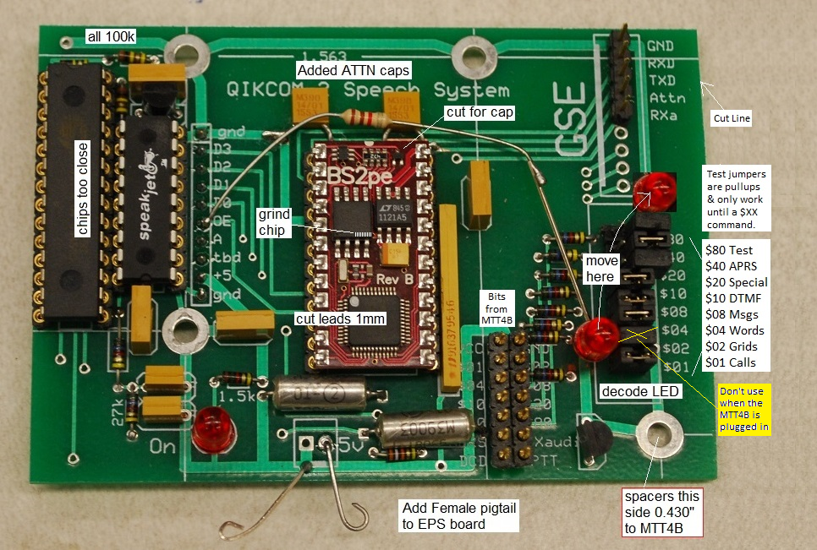

Figure 16. The APRStt DTMF and Speech System board.
The DTMF and Speech System Board shown in Figure 16 has test jumpers for all 8 of the MTT4B command bits ($XX). But these test jumpers are weak pullups and will only work when the $XX command has not been sent because in that case, the $XX bits from the MTT4B are floating. But once a command has been given, then they take on the $XX values and not from the weak test jumpers. The prototype shown above also has a temporary LED connected to the DTMF “available” line to indicate when a DTMF digit has been decoded. The flight version of the use of these bits are as follows:

$01 - High to enable DTMF Grids but only if also NOT APRS. Indicated by “READY.”
$02 - Not Used, held high. Is used by MTT4B for setting radio frequency
$04 - Turns on ProWord “from” when callsign is spoken (“grid” now on always).
$08 - Must be high to enable Messages. Indicated by “READY.OK”
$10 - Routed to EPS board to turn on VOX power
$20 - Not Used. Used on MTT4B to switch Configuration Banks
$40 - APRS-to-Speech Enabled (overrides $01 if on)
$80 - Authorizes Voice Bulletin Upload if checksum matches too

DTMF Receiver and decoding: The overall block diagram of the QIKCOM-2 speech processing system is shown before in Figure 5. The dual tone multi frequency (DTMF) receiver is an integral part of the new QIKCOM-2 capability as it allows users to send touch tone bursts to the spacecraft. These touch tone messages are on a different uplink frequency 145.980 MHz (shared with FOX1 AMSAT) than the APRS channel to minimize data collisions. The primary function of the DTMF decoder is to decode the DTMF touch tones that are sent up by amateur radio users, translating them into both APRS for inclusion in the APRS packet downlink but also acknowledged with speech. The DTMF decoder chip is located on a board with a separate VHF Receiver underneath. This Receiver is a COTS product with only minimal sensitivity (-106 dBm) which is trimmed as shown with the red lines in Figure 17 representing the portion of the DTMF board on the left used for flight.

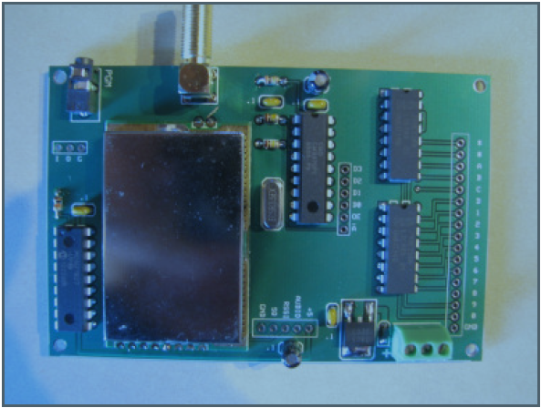
DTMF
VHF RX

Figure 17. DTMF and VHF Receiver, with red line representing removed portion

APRStt (Touchtone) CPU: For the DTMF data traffic, the BS2pe CPU captures the DTMF data and sends the extracted data both to the MTT4B for downlink in APRS format and to the Text to Speech (TTS) Chip to be spoken in a format understandable by the user. This will allow the DTMF data to be sent to Earth in two forms; voice for feedback to DTMF users in the footprint and APRS text to the global APRS internet linked system. When DTMF uplink is off and the module is in APRS-to-speech mode, the message spoken is not duplicated back down on APRS. Also in this mode, the APRS-to-Speech message is ignored if there if the MTT4B also digipeats the packet. (Should this be corrected in future MTT4B firmware settings?)

The CPU receives configuration inputs from the MTT4B in accordance with additional command functions. The CPU used in QIKCOM-2 is the Parallax BS2pe (16 page Basic Stamp), and is shown below in Figures 18 and 19 with the mapping of these command pits to CPU pins.

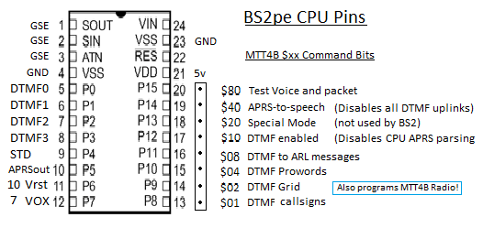
Figure 18. CPU Basic Stamp Pin Assignments - FOUO

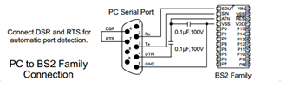
Figure 19. The GSE Serial Port requires 2 capacitors for on the reset line proper programming.

DTMF Position Reporting:

While APRS radios automatically insert their GPS position into their APRS packets, all other amateur satellite users typically report their position via a global 4 (or 6) character system called the Maidenhead grid square. This entrenched system uses two letters to break the world down into 26x26 different 60 mile grids and then the two numbers break that down further into 6 mile blocks. The grid system is based on the Lat/Long grid so the actual size of each grid varies with latitude becoming smaller towards the poles. To send these first two letters would require two DTMF keys each to encode. QIKCOM-2 reduced these two letters to only 2 digits total by identifying the top 99 grids in the world that have actual user populations as shown in Figure 20 and then translating according to that table any two letter combination into a pair of digits between 00 and 99.

Using the map shown in Figure 20, the first two digits correspond to the 99 populated grids illustrated in the outlined areas, the first digit representing the greater continent, the second defining the order of its appearance as read from left to right, top to bottom in said area. For example, central Alaska in the “0x” group (Canada and Alaska) will be identified by 01, and the state of Maine will be identified in the USA group “1x” as 13.

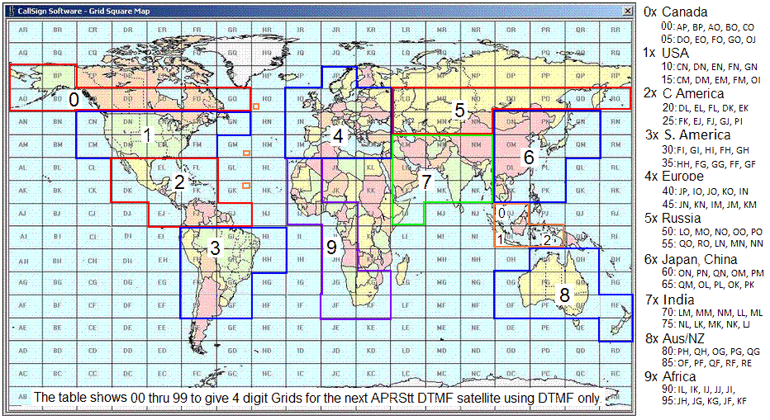
Figure 20. Worldwide APRS Map for QIKCOM-2

The second two digits of the grid square are used as-is from the Maidenhead grid system to indicate which 10 x10 grid within the lettered block. The lower left subgrid is 00 and the upper right subgrid is 99. For example, the furthest bottom left region of Box FN will be 1300, while the furthest top right portion will be 1399.
The APRS Grid Square Packet Format: WB4APR>APRS:>FM19AA/G

Downlink Grid Format: The APRS format for a user grid square report is shown above. Unfortunately, the APRS grid square packet format requires a 6 character grid and so those lower level extra two bytes are filled with “AA”. To transmit that APRS DTMF grid report from a DTMF user with his own callsign, the data has to be embedded into a QIKCOM-2 down link packet using the APRS 3rd-party format. This places the DTMF users synthesized APRS grid square packet as a data field within a normal packet originated by QIKCOM-2 as defined in the APRS Spec page 85. To preserve the originating callsign and the 3rd party senders callsign, the APRS-IS requires a pseudo header to identify this type of routing. This format shows that the packet is being transmitted by QIKCOM-2 to the APRS destination address of “APS” having been injected by the APRS touchtone network identified as “TT” and inserted by the callsign “QK2” into the APRS-IS as follows:

Downlink 3rd party Grid Format:
QIKCOM-2>APDTMF,ARISS:}WB4APR>APS,TT,QK2*:>FM19AA/G CQ#x

To decode the 4-digit grid square to a latitude and longitude, follow the procedures outlined below. L_{lat} and L_{long} refer to the corresponding integer to the letter in the grid square, i.e. F is equal to 6.

Grid Square: L_{long} L_{lat} #_{long} #_{lat}
Longitude | Latitude
- #_{long} * 3 = R  - L_{long} – 1 = X₁  - X₁ * 20 = X₂  - X₂ + R = X₃  - X₃ – 180 = Longitude | - L_{lat} – 1 = Y₁  - Y₁ * 10 = Y₂  - Y₂ + #_{lat} = Y₃  - Y₃ – 90 = Latitude

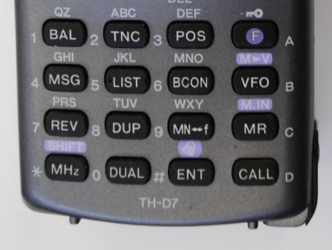
DTMF Callsign Encoding: DTMF keypads (figure 20) evolved in radios decades ago for making auto-patch telephone calls and as such needed to generate the typical 10 digit telephone numbers plus some control keys. This resulted in most radios having the full 16 key DTMF key pad. In addition, to include a full telephone number and some of these control codes in convenient pre-loaded memories, the DTMF memory size in most radios is 16 digits. Our requirement was to encode the user’s position and callsign and control codes onto 16 digits. Using the four-digit position reporting described above, it was not possible to send both one’s position and alphanumeric callsign in a 16 digit packet given current methods. The encoding method shown below is the solution to this issue:

QIKCOM-2 Keypad Format Figure 21.
*GGGGCCCCCCxxxx#

In this 16 digit string, the four G’s represent the 4 digit position code, the 6 C’s represent a callsign spelled directly on a DTMF keypad, and the 4 x’s represent a 4 digit “keycode” that encodes the position of these letters on each key of the user’s callsign. It is critical that users apply the keypad combination shown in Figure 6, where the Q and Z are located at key 1, as opposed to the keypads where QPRS is located at key 7 and WXYZ are located at key 9. Although this may appear restrictive, it is insignificant, since the radio user only has to use this code once during the programming of his callsign into the DTMF memory.
For example, the callsign WB4APR would have the 6-CCCCCC letter digit keys of 924277 and the 4-xxxx combination keycode of 1558. The encoding of the1558 from 12-digit binary to a 4 digit decimal number is illustrated in Table 6.

Table 6. Callsign decoding example
Callsign | W | B | 4 | A | P | R
Letter Key | 9 | 2 | 4 | 2 | 7 | 7
Letter positions | 1 | 2 | 0 | 1 | 1 | 2
2-bit Binary value | 01 | 10 | 00 | 01 | 01 | 10
Weight | 1024 | 256 | 64 | 16 | 4 | 1 | code
Sum | 1024 | 512 | 0 | 16 | 4 | 2 | 1558

The six Letter Key digits are just the keys with the letter on it. The letter position is just the position of that letter on that key. For example the letter W is the first position on the “9” key. The letter “B” is the 2nd letter location on the 2 key, and so on. Any decimal digit in a callsign is considered location “0” on that key, as shown in Table 6. Since these letter positions are between 0 to 3, then a two-bit value can represent them. The result is a 12 bit binary number with each 2-bits being weighed as shown. Multiplying the weights and summing them, gives the “keycode” for that call as 1558.

DTMF to Speech Position Protocol: There are two text-to-speech protocols for the voice synthesizer. First is the simple voice feedback for the DTMF users where QIKCOM-2 will speak the GRID and CALLSIGN if bit $01 from the MTT4B is set. If $04 is set then it will include the pro-word “from” between the grid and callsign. Bit $08 enables DTMF Messages to be sent and spoken.

DTMF to Speech Messages: The $08 Message capability allows the DTMF user to send common messages. Since most of everything you ever hear on amateur radio has usually been said before, we pre-loaded the top 99 phrases and sentences on the spacecraft and just refer to them by 2 digit number. This includes the over 50 pre-defined ARL radiograms standardized over many decades to allow efficient (compact) relay of common messages. For example, ARL #51 translates as “Having a wonderful time” and ARL #1 in the emergency category translates as “We are safe, all is well”. QIKCOM-2 has all of these messages plus others on file as shown in Appendix E and the DTMF user can send one of these messages by sending the following message format:
CMMxxCCCCCCxxxx#

Where the beginning “C” DTMF key indicates a message and the “MM” is the two digit message number. This message will be spoken as “CCCCCC says Message number MM . . . . ” where … is the spoken text of the message. The two digit xx is a pair of modifier digits that are automatically inserted into the pre-defined message if the message contains the “_” underscore placeholder. For example the message “There are _ of us” would be expanded to “There are xx of us”. If the message has no “_” in it, then the xx digits are ignored. The same message text is also sent on the APRS downlink using this format:

QIKCOM-2>APRSAT,ARISS:}CCCCCC>APS,TT,QK2*::ALL-ARL :MM message text

Special CQ – QSL Message: For answering a GRID CQ, there is a special message number 41 that allows you to put in the CQ number of another station and then quickly hit the DTMF memory to speak “QSL your CQ number XX.” To facilitate that, a special code is used so that the order of the MM digits and the XX digits can be reversed so the “41” can be part of the pre-recorded callsign, and the sender only has to manually enter 3 keys: BXX for the CQ umber XX and then hit DTMF memory with Message number 41 or 42 stored.

BxxMMCCCCCCxxxx#

Text to Speech APRS messaging: [This mode cannot be active at the same time as the $01 DTMF bit since the tight-detection loop of the CPU cannot scan both the DTMF input and packet input at the same time]. APRS has a well-defined messaging protocol. In this mode QIKCOM-2 can simply convert incoming packet text messages directly to speech. If the APRS user sends an APRS text message to “:QIKCOMsay:” and the first 11 bytes are “CCCCCC sez ” then QIKCOM-2 will convert the text message to speech on the downlink. If a callsign is not included (padded to 6 bytes) then the message is invalid and the CPU responds on packet with “Who sez?”. This function is turned on and off with bit $40 from the MTT4B.

It will speak the message line number if sent! (fixed in PSAT2)

UPLOADING A Voice BULLETIN? Added this paragraph Mar 2017 after looking at code.
The format is “:QIKCOMsay:XXXX456QST: text…” that writes this to Voice Bulletin Memory?! But it checks the 456 for a checksum to see if 45 summed = 6 modulo 31??? Found an example where WB4APR8QST is a match between “PR” and “8”. To cancel a message send a null message “QST:.” Then it effectively cancels the voice bulletin.

This only works if the $80 command authorization bit is set. But even if not stored, it may still be spoken (fixed in PSAT2)
The message must end with a “.” So that it truncates the memory SAY at the end.
Emergency Messages: Normally the ARL messages numbered 01 to 39 are considered emergency messages. If these are used then the XX bytes should be set to any number 90 or above and should be set to 99 if it is a true emergency. For XX=90 or above, the proword “Test” is used. If the XX=99 then it will precede the message with the word “Emergency“.

DTMF Uplink Analysis: It takes about 3 seconds at least for a practiced operator to send a DTMF gridsquare transmission. Since the DTMF users cannot hear any other users, their uplinks must be as short as possible to minimize collisions on the uplink. A manually entered DTMF string of 16 key presses can take as long as 10 seconds. The same DTMF string sent from DTMF memory can take only 3 or 4 seconds depending on DTMF memory sending speeds. As delivered, the DTMF decoder can only operate reliably at the slow speed. We experimented with changing the RC time constant on the DTMF decoder chip to try to speed up the decode to the faster DTMF rate, but it was not reliable.

Speech System Software: The BS2pe CPU loops forever looking for either DTMF or APRS data (not both at the same time) and then checks the 8 status bits from the MTT4B !OUT $XX command bits to decide how to speak or act on the DTMF (or APRS packet). Here are all the conditionals:

DO IF C01dtmf=1 THEN GOSUB Check and do DTMF
IF C40aprs= 1 THEN GOSUB CkAPRS
Every 4 minutes send Voice Bulletin if exists and DTMF Call log if in DTMF mode
LOOP

Notice that the $20, $10, and $02 bits are not used in the Speech System CPU. The $20 bit switches between bank0 and bank 1 (if $00), $10 is the backup Speech-ON control to the EPS and $02 bit is used internally by the MTT4B for frequency control.

Spacecraft-to-email Status Reporting: This mission (not implemented due to code limit) demonstrates the concept of automomous spacecraft operations. QIKCOM-2 will send an Email a few times a day to report the status and health and welfare of the spacecraft (actually, the number of new users) to the Naval Academy operators. No matter where transmitted, this packet will be received by any ground stations in view in the APRS-IS (Internet System). There, in the APRS-IS system, the APRS Email –Engine will recognize the email format and convert it to standard message transfer Protocol (SMTP) and email it to the project mentor (WB4APR@amsat.org). Since the transmission is timed its reception is statistical and not guaranteed. So the email will be sent once every 15 minutes which might assure a reasonable chance that it is heard at least once a day over the primary operating footprints (the USA and Europe). Since a typical pass lasts about 8 to 10 minutes, this keeps the number of duplicate receptions low and will hopefully assure at least once a day reporting. The data reported will be the cumulative number of new calls heard on the DTMF system. The format will be:

QIKCOM-2>APRSAT,ARISS::EMAIL----:wb4apr@amsat.org Calls.NNN

References:

[1] http://aprs.org/qikcom-2.html USNA Satellite Lab
[2] http://aprs.org/pcsat.html PCSAT-1 operational since 2001
[3] http://aprs.org/pcsat-2.html PCSAT-2 operational on ISS for 1 year misssion
[4] http://aprs.org/ande.html ANDE deployed from ISS in 2006
[5] http://aprs.org/raft.html RAFT deployed form ISS in 2006
[6] http://aprs.org/psat.html PSAT operational since May 2015
[7] http://aprs.fi APRS Internet System Public web portal
[8] http://aprs.org/aprstt.html APRS Touchtone system concept
[9] http://pcsat.aprs.org Live downlink from all USNA spacecraft
[10] http://ariss.net Live downlink from APRS via thee ISS transponder
[11] http://aprs.org The APRS protocol page
Appendix E Preloaded QIKCOM-2 Amateur Radio Messages (01 to 99)

Wherever a “_” appears, then the number “xx” will be inserted
If XX is 90 or more, then the pro-word TEST is included.
If XX is 99, then the pro-word EMERGENCY is included
DATA "01 Everyone is safe, Do not worry."
DATA "02 I am Coming home as soon as posseble." '
DATA "03 In hospetal, Receiving care and recovering."
DATA "04 Only slight property damage here, Do not worry."
DATA "05 I am moving to a new location, Will make contact then." 'new???
DATA "06 Will contact you as soon as posseble."
DATA "07 Please reply by Amatur Radio."
DATA "08 Need additionel radio equipment for emergency use."
DATA "09 Additionel _ radio operators needed." 'operations???
DATA "10 Please standby for further information."
DATA "11 Establish Amatur Radio contact on _ meeters."
DATA "12 Ankchus to hear from you."
DATA "13 Medicel emergency sit uation egsits here."
DATA "14 Sit uation here is worsening and becoming criticel."
DATA "15 Please adv eyeze your condition and what help is needed." '725
DATA "16 Property damage is very significant."
DATA "17 RE ACT communications are on channel _."
DATA "18 Please contact me as soon as posseble."
DATA "19 Request halth and welfare report."
DATA "20 Temporarily stranded, Will need some assistance."
DATA "21 Serch and Rascue assistance is needed."
DATA "22 Need accurate information on conditions at your location."
DATA "23 Report accessebility and best way to reach your location."
DATA "24 Evacuation of razidents from here is urgently needed."
DATA "25 Please adv eyeze weather conditions at your location."
DATA "26 Need help and care for evacuation of sick and injured." '1260
DATA "27 Hi, This was Dove in spaice, anni verse air E"
DATA "28 There are _ of us here."
DATA "29 ."
DATA "30 Marytime Emergency Code number _." '
DATA "31 We are operating on emergency power."
DATA "32 We are operating on sowlar power."

DATA "33 This is a voice test."
DATA "34 ."
DATA "35 ." '33 through 45 still availalble and there is room for the 18
DATA "36 ."
DATA "37 ."
DATA "38 ." 'omit 39 for testing messge not found...
DATA "40 C Q Satellite, my Q S O number is %." 'QSO msg
DATA "41 Q S L, your C Q number _." 'QSO msg
DATA "42 Q S L, your C Q number _ and thanks for the contact." 'QSO msg
DATA "43 Go Navy, beet Army!." '''
DATA "44 Navy Beets Army by _." ''
DATA "45 I am _ years old."
DATA "46 Greetings on your berthday." 'birthday to bertday
DATA "47 Got your message number _."
DATA "48 I am in school grade _." ''
DATA "49 Celebrating _ munths in spaice."
DATA "50 Greetings by Amatur Radio." 'Amateur to Amatur
DATA "51 Am having a wonderful time."
DATA "52 Really enjoyed visiting with you."
DATA "53 Received your package, Thank you."
DATA "54 Many thanks for your good wishes."
DATA "55 Very delighted to hear your good newze." '535
DATA "56 Congratulations on your worthy achievement."
DATA "57 Wish we could be twog ether." 'sounds better
DATA "58 Have a wonderful time, Let us know when you return."
DATA "59 Congratulations on the new arrivel, Hope all are well."
DATA "60 Wishing you the best."
DATA "61 Wishing you happy holidays and New Year."
DATA "62 Greetings and best wishes for the holiday season."
DATA "63 Our best wishes are with you, Hope you win."
DATA "64 Arrived safely at _ hours."
DATA "65 Please meet me on arrival at _ hours."
DATA "66 D X Q S Ls are on hand at the Q S L Bureau."
DATA "67 Your message _ is undelivereble."
DATA "68 Best wishes for a speedy recovery."
DATA "69 Welcome, We hope you will enjoy the fun and fellowship."
' thats the end of the numbered ARL radiograms
' this is the limit of the D72 display space --------------------|
DATA "70 Call me ON my cell at _ Oh clock."
DATA "71 No cell phone service here."
DATA "72 My Cell phone battery is dead."
DATA "73 Greetings from AMSAT, Keeping ham radio in spaice fo _ years."
DATA "74 My Cell phone charging opportunitees are limited."
DATA "75 Call my cell phone on the hour."
DATA "76 My Radio power charging capabilities are limited."
DATA "77 My next contact time will be in _ minutes."
DATA "78 My next contact time is tomorrow."
DATA "79 Please send items number _."

DATA "80 I am on schedule."
DATA "81 I may be delayed by _ hours."
DATA "82 I may be delayed by _ days."
DATA "83 I may be earlyer by _ hours."
DATA "84 I May be earlyer by _ days."
DATA "85 I may quit earlyer by _ stops."
DATA "86 I may go further by _ stops."
DATA "87 We are camping and enjoying it greatly."
DATA "88 Sending love and kisses!."
DATA "89 Contact me on the _ meeter band."
DATA "90 There are _ of us here."
DATA "91 Celebrating _ weeks in spaice."
DATA "92 ." '[Money, food, water, supplies, shoes, sleeping bag, blanket,fuel]"
DATA "93 ." '[Mom, dad, grandparents, sister, brother, uncle, aunt, friends, teacher, hamfest]"
DATA "94 ."
DATA "95 ."
DATA "96 ."
DATA "97 ."
DATA "98 ."
DATA "99 ."

Appendix F:

TYPICAL APRS DOWNLINK TRAFFIC VIA THE APRS TRRANSPONDER ON ISS
RECEIVED AT 1630 UTC ON 22 APRIL 2015
EACH PASS OF DATA REPRESENTS A SINGLE PASS OVER A POPULATED AREA ABOUT 10 MINS

Below, the Header is shown split from the data. In actual raw form, the two are concatenated.

Europe:

ON7BRT]APY350,ISS*,RS0ISS,qAR,OE5RPP: :TA1BM :ON7BRT VIA ISS {16
RS0ISS]CQ,qAR,OE5RPP: ]ARISS - International Space Station
HG8GL-4]APRS,RS0ISS*,qAR,SQ5RTW-5: Hello ISS RST 599 from Hungary
DM2DXG]CQ,RS0ISS*,qAR,SQ5RTW-5: =5153.55N/01103.10E-OP:Bernhard in Halberstadt/Harz {UIV32N}
IS0EBO-4]4P4TX3,ISS*,WIDE,qAR,SQ5RTW-5: '~[.l i/]73 FROM SPACE
TA1BM]CQ,RS0ISS*,qAR,SQ5RTW-5: =4059.78N/02855.53E-HELLO FROM ISTANBUL
SV3CIX]APU25D,RS0ISS*,CQ,qAR,SQ5RTW-5: =/;Pe;T9jH` BOp.Stavros To all via iss ( ( ( 73s) ) )
2M0IBO]CQ,RS0ISS*,qAR,SQ5RTW-5: =5738.38N/00317.85W-73' Via iss. www.2m0ibo.com {UISS52}
2M0IBO]CQ,RS0ISS*,qAR,OE5RPP: :ALL :Greetings from Scotland, IO87ip, 73 de Jon.
HG8GL-4]APRS,RS0ISS*,qAR,SQ5RTW-5: Hello ISS RST 599 from Hungary
TA1BM]CQ,RS0ISS*,qAR,SQ5RTW-5: =4059.78N/02855.53E-HELLO FROM ISTANBUL
DM2DXG]CQ,RS0ISS*,qAR,OE5RPP: =5153.55N/01103.10E-OP:Bernhard in Halberstadt/Harz {UIV32N}
OE6PWE]APZWPP,RS0ISS*,qAR,ON7EQ-10: =4659.08N/01527.57E-73's Via ISS, wolfgang.puhar@chello.at
RS0ISS]CQ,qAR,ON7EQ-10: ]ARISS - International Space Station
TA1BM]CQ,RS0ISS*,qAR,ON7EQ-10 :=4059.78N/02855.53E-HELLO FROM ISTANBUL
ON7BRT]5Q0SS5,ISS*,RS0ISS,qAR,ON7EQ-10: `yHol y/`ON7BRT ON7BRT@skynet.be_"
HG8GL-4]APRS,RS0ISS*,qAR,ON7EQ-10: Hello ISS RST 599 from Hungary
TA1BM]CQ,RS0ISS*,qAR,ON7EQ-10: ON7BRT/RS0ISS via iss 73 k
OE6PWE]APZWPP,RS0ISS*,qAR,ON7EQ-10: =4659.08N/01527.57E-73's Via ISS, wolfgang.puhar@chello.at
SQ9ONX-1]UPPW82,RS0ISS*,qAR,ON7EQ-10: `.GYl#R[/`"6^}Op.Adam Qth.Belk Vy73 Via ISS SAT :)_#
ON7BRT]APY350,ISS*,RS0ISS,qAR,ON7EQ-10: :G7UZN :ON7BRT VIA ISS {15
ON7BRT]APY350,ISS*,RS0ISS,qAR,ON7EQ-10: :F4GUK-1 :ON7BRT VIA ISS {14
G7HCE]CQ,RS0ISS*,qAR,ON7EQ-10: :Heard :EA1OC,F4GUK-1,OE6PWE,DM2DXG,ON7BRT{UISS53}
F4GUK-1]APX200,RS0ISS*,qAR,ON7EQ-10: =4849.03N/00233.11E`73 from Paris
PE1NTN]CQ,RS0ISS*,qAR,ON7EQ-10: =5220.85N/00450.75E-JO22ki - Amsterdam - pe1ntn@amsat.org
G7HCE]CQ,RS0ISS*,qAR,ON7EQ-10: Hello To All Via ISS 73' David in Exeter
TA1BM]CQ,RS0ISS*,qAR,ON7EQ-10: =4059.78N/02855.53E-HELLO FROM ISTANBUL
OE6PWE]APZWPP,RS0ISS*,qAR,ON7EQ-10: =4659.08N/01527.57E-73's Via ISS, wolfgang.puhar@chello.at
ON7BRT]APY350,ISS*,RS0ISS,qAR,ON7EQ-10: :G7UZN :ON7BRT VIA ISS {15
IS0EBO-4]4P4TX3,ISS*,WIDE,qAR,ON7EQ-10: '~[.l i/]73 FROM SPACE
DM2DXG]CQ,RS0ISS*,qAR,ON7EQ-10: =5153.55N/01103.10E-OP:Bernhard in Halberstadt/Harz {UIV32N}
RS0ISS]CQ,qAR,ON7EQ-10: ]ARISS - International Space Station
G7UZN]U1SRYU,RS0ISS*,qAR,ON7EQ-10: 'va9l -/]=
F4GUK-1]APX200,RS0ISS*,qAR,ON7EQ-10: =4849.03N/00233.11E`73 from Paris
G7HCE]CQ,RS0ISS*,qAR,ON7EQ-10: Hello To All Via ISS 73' David in Exeter
IS0EBO-4]4P4TX3,ISS*,WIDE,qAR,ON7EQ-10: '~[.l i/]73 FROM SPACE
ON7BRT]5Q0SS5,ISS*,RS0ISS,qAR,ON7EQ-10: `yHol y/`ON7BRT ON7BRT@skynet.be_"
G7HCE]CQ,RS0ISS*,qAR,F4GUK-1: =5042.86N/00329.10W-73' David in Exeter/UK {UISS53}
OE6PWE]APZWPP,RS0ISS*,qAR,F4GUK-1: =4659.08N/01527.57E-73's Via ISS, wolfgang.puhar@chello.at
IS0EBO-4]4P4TX3,ISS*,WIDE,qAR,F4GUK-1: '~[.l i/]73 FROM SPACE
RS0ISS]CQ,TCPIP*,qAS,SM5RVH: ]ARISS - International Space Station
RS0ISS]CQ,qAR,VK3KAW-4: ]ARISS - International Space Station

Eastern Europe:

OE6PWE]APZWPP,RS0ISS*,qAR,SQ5RTW-5: =4659.08N/01527.57E-73's Via ISS, wolfgang.puhar@chello.at
HG8GL-4]APRS,RS0ISS*,qAR,SQ5RTW-5: Hello ISS RST 599 from Hungary
DL6SDA]CQ,RS0ISS*,qAR,SQ5RTW-5: =4906.27N/00907.71E-73 via ISS
OE6PWE]APZWPP,RS0ISS*,qAR,SQ5RTW-5: =4659.08N/01527.57E-73's Via ISS, wolfgang.puhar@chello.at
RS0ISS]CQ,qAS,EA6XQ: ]ARISS - International Space Station
SQ9ONX-1]UPPW82,RS0ISS*,qAR,OE5RPP: `.GYl l[/`"6a}Op.Adam Qth.Belk Vy73 Via ISS SAT :)_#
PE1NTN]CQ,RS0ISS*,qAR,ON7EQ-10: =5220.85N/00450.75E-JO22ki - Amsterdam - pe1ntn@amsat.org
DM2DXG]CQ,RS0ISS*,qAR,HG8GL-6: =5153.55N/01103.10E-OP:Bernhard in Halberstadt/Harz {UIV32N}
HG8GL-4]APRS,RS0ISS*,qAR,ON7EQ-10: Hello ISS RST 599 from Hungary
OE6PWE]APZWPP,RS0ISS*,qAR,ON7EQ-10: =4659.08N/01527.57E-73's Via ISS, wolfgang.puhar@chello.at
ON7BRT-9]UQ0SS5,RS0ISS*,qAR,ON7EQ-10: `yKin6ZR/`"3s}ON7BRT/M DEFENDER 110 LANDROVER_"
DL6SDA]CQ,RS0ISS*,qAR,ON7EQ-10: :EA7AHA :73 de Wolfgang DL6SDA
ON7BRT-9]UQ0SS6,RS0ISS*,qAR,ON7EQ-10: `yKtm|]R/`"3v}ON7BRT/M DEFENDER 110 LANDROVER_"
PE1NTN]CQ,RS0ISS*,qAR,ON7EQ-10: =5220.85N/00450.75E-JO22ki - Amsterdam - pe1ntn@amsat.org
DM2DXG]CQ,RS0ISS*,qAR,ON7EQ-10: =5153.55N/01103.10E-OP:Bernhard in Halberstadt/Harz {UIV32N}
OE6PWE]APZWPP,RS0ISS*,qAR,ON7EQ-10: =4659.08N/01527.57E-73's Via ISS, wolfgang.puhar@chello.at
DO1RFR-6]5P1W99,RS0ISS*,qAR,ON7EQ-10: ''Sll -/]OM Frank best 73! VIA ISS http://do1rfr.de=
RS0ISS]CQ,qAR,ON7EQ-10: ]ARISS - International Space Station
DL6SDA]CQ,RS0ISS*,qAR,ON7EQ-10: :EA7AHA :73 de Wolfgang DL6SDA
EA7AHA]SVUQRS,RS0ISS*,qAR,ON7EQ-10: '{/6l -/]via SAT=
OE6PWE]APZWPP,RS0ISS*,qAR,IS0AML-6: =4659.08N/01527.57E-73's Via ISS, wolfgang.puhar@chello.at
RS0ISS]CQ,qAR,F4GUK-1: ]ARISS - International Space Station
EA7AHA]SVUQRS,RS0ISS*,qAR,IS0AML-6: '{/6l -/]via SAT=
F8NHA-6]CQ,RS0ISS*,qAR,IS0AML-6: =4410.87N/00247.24E`73,S-CHRISTIAN/JN14JE/INFO:QRZ.COM
DL6SDA]CQ,RS0ISS*,qAR,IS0AML-6: 73 via ISS de Wolfgang, DL6SDA
EA7HYC-9]SVQRUQ,ISS*,R0ISS,qAR,EA1JL-3: `{3bl -/`ea7nyc@gmail.com for qsl_%
EA1JL]APRS,RS0ISS*,qAR,EA1JL-3: :DL6SDA :Very good signal friend.Good luck.73
DL6SDA]CQ,RS0ISS*,qAR,IS0AML-6: =4906.27N/00907.71E-73 via ISS

Chile:

CE3EKW-9]S3P43S,ISS*,W2-2,qAR,LU2HAM-1: `c=,oIC]/]"7N}MARCO BELTRAMI CE2EKW@YAHOO.ES =
CE3EKW-9]S3P40X,ISS*,W2-2,qAR,LU2HAM-1: `c=Dn]_]/]"7I}MARCO BELTRAMI CE2EKW@YAHOO.ES =
CE3EKW-9]S3P37T,ISS*,W2-2,qAR,LU2HAM-1: `c=@oIM]/]"78}MARCO BELTRAMI CE2EKW@YAHOO.ES =
CE3EKW-9]S3P36U,ISS*,W2-2,qAR,LU2HAM-1: `c=GoqM]/]"7)}MARCO BELTRAMI CE2EKW@YAHOO.ES =
RS0ISS]CQ,qAR,LU2HAM-1: ]ARISS - International Space Station

Russia:

UA0SNV-6]APRS,RS0ISS*,qAR,UA0SNV-1: =5758.45N/10237.30E-Ust'-Ilimsk, Vasily. {UISS53}
UA0SNV-6]APRS,RS0ISS*,qAR,UA0SNV-1: ;ISS *123728z4524.00N\08934.00ES AutoTx Object via UA0SNV
RS0ISS]CQ,qAR,UA0SNV-1: ]ARISS - International Space Station
UA0SNV-6]APRS,RS0ISS*,qAR,UA0SNV-1: =5758.45N/10237.30E-Ust'-Ilimsk, Vasily. {UISS53}
UA0SNV-6]APRS,RS0ISS*,qAR,UA0SNV-1: ;ISS *123643z4643.00N\08601.00ES AutoTx Object via UA0SNV
UA0SNV-6]APRS,RS0ISS*,qAR,UA0SNV-1: =5758.45N/10237.30E-Ust'-Ilimsk, Vasily. {UISS53}
UA0SNV-6]APRS,RS0ISS*,qAR,UA0SNV-1: ;ISS *123558z4754.00N\08217.00ES AutoTx Object via UA0SNV
UA0SNV-6]APRS,RS0ISS*,qAR,UA0SNV-1: =5758.45N/10237.30E-Ust'-Ilimsk, Vasily. {UISS53}
UA0SNV-6]APRS,RS0ISS*,qAR,UA0SNV-1: ;ISS *123513z4858.00N\07823.00ES AutoTx Object via UA0SNV
RS0ISS]CQ,qAR,UA0SNV-1: ]ARISS - International Space Station

Israel and Asia:

Z4DP]SQTQ90,RS0ISS*,qAR,HG8GL-6: '?_Dl `/]73 de Dovid=
4Z4DP]SQTQ90,RS0ISS*,qAR,HG8GL-6: '?_Dl `/]=
UR4QS]CQ,RS0ISS*,qAR,HG8GL-6 =4642.06N/03509.66E-cq de ur4qs pse k. {UISS53}
HG8GL-4]APRS,RS0ISS*,qAR,SQ5RTW-5: Hello ISS RST 599 from Hungary
RS0ISS]CQ,qAR,4Z4DP: ]ARISS - International Space Station
4Z4DP]SQTQ90,RS0ISS*,qAR,SQ5RTW-5: '?_Dl `/]73 de Dovid=
4Z4DP]SQTQ90,RS0ISS*,qAR,SQ5RTW-5: '?_Dl `/]=
RS0ISS]CQ,qAR,SQ5RTW-5: CMD(B/H/J/K/KM/L/M/R/S/SB/SP/ST/SR/V/?)]
RS0ISS]CQ,qAR,SQ5RTW-5: Logged on to RS0ISS's Personal Message System
UR4QS]CQ,RS0ISS*,qAR,SQ5RTW-5: =4642.06N/03509.66E-cq de ur4qs pse k. {UISS53}
UR4QS]CQ,RS0ISS*,qAR,HG8GL-6: cq de ur4qs k
HG8GL-4]APRS,RS0ISS*,qAU,DC9RD-10 :Hello ISS RST 599 from Hungary

