EA467 Antenna Design using EZNEC (rev a) Fall 2016

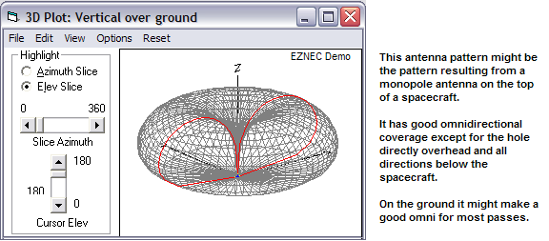
Intro: Antennas are a significant aspect of your spacecraft design. Big antennas can significantly impact the structure and pointing requirements. Conversly, small/simple antennas are affected by other surfaces of the spacecraft which are part of the near field of the antenna and have significant impact on the antenna radiation patterns. The omni-directional antenna for command and control usually falls into the latter category with significant pattern effects.

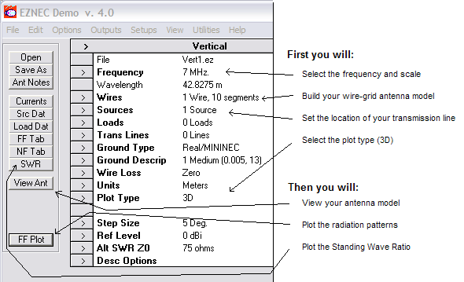
To model the radiation pattern of your antenna and the impact of surrounding surfaces, we use the EZNEC antenna analysis program installed on the PCs in RI-122. NEC stands for Numeric Electromagnetic Code and gives a finite element analysis method for predicting the performance of antennas.

EZNEC sums up the contributions of all the RF currents flowing in all surfaces of an object to calculate the resulting far-field radiation pattern. You will use this program to explore the basic fundamentals of antenna patterns and gain and then will develop a project using it. Above is the EZNEC main control panel.

CAUTION: We all will use the basic starting files. PLEASE make sure that you do not SAVE a modified file over the top of our standard files. After loading, Please change the name of the file to your file name and save it on your own workspace.

TEAMS: All RI-119 workstations have EZNEC, so you will work individually on this portion of the Antenna Lab.

IMPORTANT - CAPTURING IMAGES: In working through this assignment, you will take snapshots of SWR plots and 2-D & 3-D plots of antenna patterns. Save these EZNEC images for potential use in your Antenna Lab report by using COPY under the VIEW menu, and then paste these plots into a WORD document. Then save the file to your drive or email it to yourself.

Antenna Models: A “solid model” of a spacecraft is constructed in EZNEC as a wire grid of small segments (see Cubesat model below). To limit the number of points (processing load), gaps between wire segments that are smaller than about 0.1 wavelength are sufficient to give a reasonably close approximation to a solid surface. EZNEC is limited to 500 segments which is surprisingly easy to use up. You will use the WIRES tab to build your antenna model, and SOURCES to set the location of your antenna feed point. The location of each wire in the model is specified by the XYZ coordinates of the end points. Below left is a simple model of a ¼ wave monopole over an infinite ground plane, and on the right, that same monopole mounted on the top of a cubesat in free space. The purple line represents the distribution of current on the wire and can be turned off to simplify views.

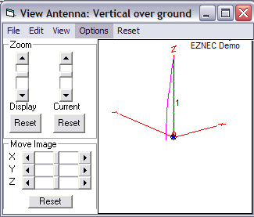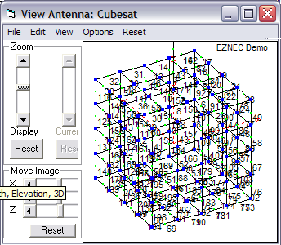
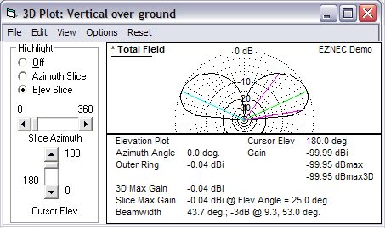
3D Pattern Plots as shown on the first page, can be viewed and rotated to any angle. Be sure “Step Size” is set to 5 deg. Similarly a 2D plot is also provided that contains a number of numeric results such as the maximum gain of the main lobe and the 3 dB beam width as shown here.

Part A: Simple Dipole Antennas

The simplest antenna is a ½ wave dipole fed at the center. It can be built to correspond to standard transmission line characteristic impedances near 75 or 50 ohms depending on its exact diameter and length (e.g. building it thicker usually lowers the impedance and reduces the length required for ½ wave resonance slightly. In this experiment you will build an EZNEC model of one and then two 50 Ω dipole antennas fed in phase as shown below (and as you will use in next week’s antenna lab). Notice how this dual antenna uses two 3/4 wave transmission lines to combine the two antennas in parallel while maintaining the 50 ohm match as you learned in last week’s lab. (Using two ¼ wave lines would give the same correct impedance but constrain the dipoles to be too close together).

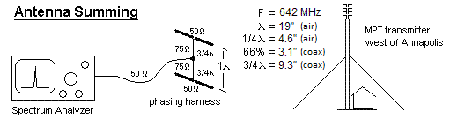

- OPEN lab-dipole-dual642.EZ (found on Blackboard). Then immediately use SAVE-AS and save it under your own file name in your workspace.
- View the antenna and then set PLOT TYPE to 3D. Next view the Far Field plot and rotate as needed to visualize the donut pattern.
- Click “show-2D plot” to see the max gain and 3dB beamwidth (copy and save it). Click on various points on the plot to see the relative signal strength at different angles. See if you can find the -3dB points on the plot to verify the 3dB beamwidth or change the VIEW to add the beamwidth lines.
- Click WIRES and see the dimensions of this wire model
- Click SRC DAT to see that this dipole is fed in the center of the wire
- Click SWR to generate a plot between 600 to 680 MHz. The plot shows SWR just like you manually determined using the TUNE knob on the antenna analyzer in the Transmission Lines lab. Click on the center frequency to see the SWR at that point (1.4) and impedance (R=71 and X=j3 Ohms).
- Now add a second dipole 19” above the first as shown in the above diagram as follows…
- Use WIRES tab to WIRE-COPY #1 with a +19” Z offset
- Use SOURCES tab to confirm that it also copied a source with wire 2 also
- Repeat steps 2 and 3 to see how dual antennas add to create gain lobes and interfere to create nulls.

Ground Reflections: The nearness to ground or large flat surfaces can significantly affect antenna patterns as well/ Continue with the above model by using the GROUND-TYPE to change from free-space to perfect ground. Repeat step 2 to see how this affects the pattern with even more lobes and nulls. Fortunately, our spacecraft are usually in space eliminating ground reflections and making antenna predictions easier though there is still the impact of large spacecraft surfaces near the antenna.

For Antenna Lab Report: Compare these EZNEC predictions to the experimental results observed in the Antenna Lab. You can use the SWR plot and/or the 2-D & 3-D snapshots to help with your comparisons. Were you able to observe the gain lobes and nulls seen on the EZNEC plots for item 10 above? Comment on any differences.
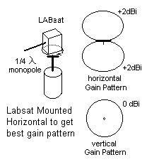

Part B: Labsat Monopole Pattern
For this experiment, a model of a LABsat with a 642 MHz ¼ wave monopole antenna will be built and its theoretical pattern from EZNEC compared with actual off-air measurements. Open the file LABsat1120.EZ and then SAVE-AS your own new filename.

- View the model to see the antenna (wire #56). Set the plot type to 3D and do a Far Field (FF) Plot to see the 3D antenna pattern. Notice the field pattern of this short 1.8” antenna has major lobes and nulls caused by the spacecraft structure because the antenna is small relative to the size of the spacecraft.

- Do an SWR plot from 1080 to 1160 MHz and see how the SWR is a good 1.06 at 1120 MHz. Go to the WIRES tab and change the end 2 x-component of wire #56 from 2.18 to 6 inches (Equivalent to changing the frequency from 1120 to 460 MHz). (Change the Frequency Tab entry to 460 MHz). Now do a 3D Far Field plot and see how much better this antenna performs as an omnidirectional antenna when the size of the antenna is larger. The pattern is now “rounder” than the original 1250 MHz antenna because the antenna length is now larger relative to the spacecraft. This demonstrates how the physical dimensions of a spacecraft can affect antenna patterns. Click on the SHOW-2D button and move the cursor and azimuth slice around to find the maximum gain of this antenna.

- Now, change this antenna wire model for our desired 642 MHz antenna (Make sure to change the Frequency Tab entry to 642 MHz). Next, use WIRES to change this antenna length (wire #56, end-2) to something a bit shorter than a quarter wavelength at 642 MHz. Now do an SWR plot from 600 to 680 MHz to find the lowest SWR. If it is above 642 MHz, your antenna is too short. If below, your antenna is too long. Change the wire length and re-do the SWR until you get the best SWR at 642 MHz (about 2.0 SWR or better). Now, continue to improve the SWR by playing with the length and diameter of the antenna (#56) and also the short source stub under it, #55. Can you get your design to have an acceptable SWR (i.e. < 1.5) at 642 MHz?

- Copy plots into your WORD document for potential use in your Antenna Lab report.

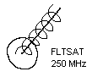
Part C: Helix Antennas: Construct an EZNEC model of the Fleetsat/UFO helix we used in the transmission lines lab for later comparison with measurements.

- Start by using the WIRES tab, and then WIRE-DELETE all wires. Wire 1 will remain. Now save the file as a NEW filename.

- Under the WIRES tab use the CREATE menu to make a helix using the dimensions (you measure) of our Fleetsat/UFO antenna. Set the position to End-1 at 0,0,0 pointing in the + Z direction Use 8 segments per turn and make the wire diameter about 0.4”.

- Change the frequency to 250 MHz. Add a perfect ground plane and then delete the original wire #1 which was an artifact from before. Now set a source in the middle of the new wire #1 (where it is connected to the ground plane). At this point, the 3D plot should look like a nice main lobe. On the 2D plot move the cursor and measure the gain of the main lobe.

- Do an SWR plot of the antenna over the frequency from 220 to 320 MHz which covers both the uplink and downlink to the FLEETSATS and UFO’s. Notice it is quite high. Next, change the Alt-SWR-Zo to 140 ohms which is the common impedance of a Helix. On the SWR plot screen, select VIEW-Controls and select ALT (140) ohms. This should improve the SWR because of the better match. Notice how flat the performance of the Helix is across this rather wide bandwidth.

- Copy plots into your WORD document for potential use in your Antenna Lab report.

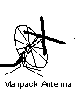
Part D. Manpack Antenna: The manpack antenna is a cross polarized pair of dipoles to optimize satellite reception when the polarization is not known. For this lab, you will build your EZNEC antenna model for only one of the UHF dipoles since the two polarizations are independent of each other.

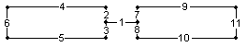
- Measure the manpack antenna with a ruler so that you have the dimensions of both the dipole, its height above its ground plane and the radius of the ground plane. Open the Dipole1.ez file as a starting point. Do a SAVE-AS to a new filename. Change the dipole (wire 1) to the 1.8” length of wire 1 in the model below and enter the 11 additional wires to fill-out a wire grid model of the dipole blades as shown below. Your source remains at the center of that short #1 segment. Place the antenna coordinates at the measured distance above the ground plane.

- To make the radials of the ground plane reflector, add one new wire at the correct –Z distance, and then use the CREATE-RADIAL tool to generate the rest. Remember to give them a correct thickness (about .3 inches). Now the hard part. Look at the wires table to see the endpoints of the radials, and manually add in the additional circumference wires of the ground plane.

- Generate 2D and 3D plots. Check the SWR across the frequency of 220 to 320 MHz and record the gain of the manpack antenna. Compare the Manpack ground plane gain pattern to the perfect ground plane. Copy plots into your WORD document for potential use in your Antenna Lab report.

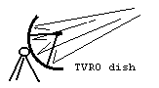
Part E: Parabolic Dish Antennas: One of the most common space antenna types is the parabola because it can be used over a variety of frequencies by only changing the feed system. The feed is usually a simple dipole in front of a small reflector at the focal point of the dish. In order to observe the antenna pattern for a feed dipole in the dish, a wire grid model of the dish has been generated. To keep the number of segments below the 500 maximum, a linear feed dipole in only one polarization is used, and therefore we only need to model the dish in that one polarization. The holes in the dish are less than 0.1 wavelength to keep within the rule of thumb for modeling a surface reflector.

- Open the file “dish.ez”. Do a SAVE-AS to your filename. The model is a deep dish with the feed dipole deep inside. Normally dishes are flatter and the focal point is approximately 40% of the dish diameter away from the center of the dish. As loaded, the feed point (wire #425) is 3 inches from the dish. Look at the Far Field and 3D plot and then 2D plot and antenna gain.

- Using the WIRES tab, adjust the height of the feed dipole (#425) and see the effect on the gain and radiation pattern. See if you can find the location of the feed to give the highest gain.

- Adjust the length and thickness of the feed dipole to get the lowest SWR at 2400 MHz. Save copies of the plots for potential use in your Antenna Lab report.

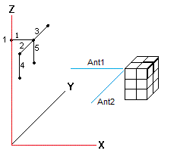
Part F. Cubesat Antenna Design:

For this part, you will design an antenna system for a cubesat similar to many that we are readying for flight. The space craft is a 4” x 4” x 6.6” rectangle. The antenna needs to be omni directional and operate at 145.825 MHz. You will build the wire model and place a ¼ wave monopole antenna on one corner. You will observe a pattern similar to a dipole pattern with two nulls. To solve this null problem, you will add a second monopole at 90 degrees to fill in the nulls and make the pattern more omnidirectional.

To keep the number of elements in the wire grid model reasonable, you will use a 2 inch grid. This is going to take over 60 elements. At first this seems very challenging since you have to enter the XYZ coordinates of each wire end point. But EZNEC has some powerful tools for copying wires. To simplify your effort, we have prepared the fundamental 5 wires for one edge of the top of the model as shown at right. The actual wires are highlighted on the model sketch. The entire spacecraft can be built up by copying, shifting and rotating these elements. Use the VIEW Antenna tab frequently to see your model grow and keep track of each block of elements you produce because some will need to be copied and re-used. You may have to change the STEP-SIZE to 5 degrees to make it easier to visualize.

Assembling the Spacecraft:
- OPEN the file named cubesat-build.EZ
- In the WIRES window, select the 4 wires that make up a row of squares along the side (#2 to 5) and WIRES-COPY them twice in the Z axis, first with Z offset of -2.2 and then again with a -4.4 inch offset to make most of a complete side.
- Next copy wires 1, 2 & 3 to the bottom (Z offset -6.6) to fill out the side and bottom.
- Now copy and rotate that side to complete the spacecraft as follows:
A. Select and WIRE COPY the complete side (wires 1-16) with zero offset (ignore error warning).
- Select the copies (17-32) and WIRE-ROTATE about Z through 90 deg (now, 2 sides done).
- Select all 32 wires (now two sides) and COPY again (ignoring error)
- Next WIRE ROTATE all of the copies (33-64) 180 deg to make the other 2 sides. Done.

Monopole ¼-wave Antenna: Put the ¼ wave monopole antenna on the 2.2.0 corner using these steps.

- Add a short 0.4 inch wire segment (64) at the feed point to use as a SOURCE from 2,2,0 to 2.4,2,0
- Add a SOURCE in the middle of this wire (64) and delete all other sources
- Add a longer wire to the end of the short wire segment that extends the total length (X) to the estimated quarter wavelength 2.4,2,0 to X,2,0
- Check the SWR over the frequency from 142 to 150 MHz

Now vary the length of the quarter wave wire by a few percent to minimize the SWR at 146 MHz. Next, vary the diameter of this wire to minimize the SWR value. These two adjustments are interactive and both have to be adjusted to find the right length. Observe and save a 3D plot of the field pattern which will have the two nulls of any typical single wire antenna. Also save a 2D plot accentuating the worst case nulls.

To eliminate the nulls, build a second monopole at 90 degrees to the first. Do this simply by copying the two wires of the antenna (short and long one), and then rotate 90 degrees about Z to build an orthogonal crossed polarized antenna. Note the antenna pattern. Still nulls right? This is because the two antennas are being fed in-phase and so the combination is still basically a dipole that now simply looks like a “V”.

To make the two orthogonal antennas independent, and thus able to combine antenna patterns, we need to add a 90 degree phase shift to one of them. Go to SOURCES and add a 90 degree phase to one of them. Now check the FAR FIELD antenna pattern. It should have significantly reduced nulls and appear like a better omni antenna. Use the 2D plot to show the worst case null and compare it in your report with the single antenna.

For Antenna Lab Report: Use the EZNEC plots and your knowledge of antenna patterns as predictions to compare with your measured antenna results from later parts of this lab. Discuss potential reasons for any differences between the EZNEC predictions and real-world observations.

